**Setting up your Development Environment: Git and Node**

# **Setting up your Development Environment**

### Software Requirements

1. **Text editor of your choice**: Any text editor that you are already familiar with can be used for editing the project files. I will be using Visual Studio Code (<https://code.visualstudio.com/>) as the editor of choice in this specialization. You may also consider other editors such as Brackets (<http://brackets.io/>), Sublime Text (<http://www.sublimetext.com/)>, or Atom (<https://atom.io/>).
2. **Browser of your choice**: You may use your preferred browser. I will be using Chrome as the browser in all the exercises. All the exercises and assignments in this course have been tested using Chrome v. 46. Please note that not all browsers may support all the HTML5 features to the same extent. You might encounter problems when using other browsers. I strongly urge you to use the latest Chrome browser for the exercises and assignments in this course so that any problems are minimized.
3. **Command line shell**: Familiarity with the command-line shell will be essential for the exercises. In Windows a cmd window or power shell with admin privileges would be needed. On a Mac or in Linux, a terminal window can be used. Please get familiar with the "sudo" command in OS X and Linux.
4. **Files required for the exercises**: We will provide additional starter files for the exercises wherever needed. Links to download the files will be provided inline in the **exercise instructions** that follow each exercise video. Please download the files provided there, if any, before beginning the exercise. The links are also available through the **Additional Resources** of the specific lesson.

### Note: Please remember to retain the folders and all the files that you create in the exercises. Further exercises will build upon the files that you create in the preceding exercises. DO NOT DELETE the files at the end of the exercises, unless otherwise instructed. You may wish to set up your exercise folder as a Git repository and commit the files to the repository at the end of each exercise.

Git is a very popular version control system for software.

We need Git for working with our node ecosystem that we're going to use throughout this specialization.

So it is important for you to get Git on to your computer. So let's go through a few quick steps to set up Git on your computer and then some quick commands to enable us to make use of Git in this specialization.

I will not go into too much details about version control and how Git works,

and so on. That is beyond the scope of this course. Instead, we'll just get some basic understanding of Git. Git is, as I said, a version control system. This is a software tool that enables us for the management of changes to source code and maintaining your version history. So as your source code evolves, you will be able to check in the code at different points of times so that you can always have a way of rolling back to a previous version, in case your updates to the code doesn't work correctly. There are various version control systems that are in use in the real world, including CVS, SVN, and

Git being a very popular mechanism for version control these days.

Where did Git originate?

Git was designed by Linus Torvalds, the person behind the Linux Operating System. Git was designed as a version control system and distributed version control system for use in Linux kernel development and it has seen much wider deployment in the real world, these days.

That node ecosystem is very much tied into Git and that is the reason why we need Git for this specialization.

Let's now move on to a Few hands on exercises, where you will first set up Git.

Then you will learn a few basic Git commands. And then also understand how you can set up an online repository in places like Git Hub or Bit Bucket for

synchronizing your source code from your computer to the online repository.

This is obviously not a comprehensive tutorial on the Git but we'll learn just

enough, that of the commands that are necessary for use in this specialization.

Let's now run through a few quick steps to set up Git on your computer.

One easy way of setting up Git on a computer is to go to this site called

git-sem.com.

And then download the Git installation files from there. So when you visit this website, git.scm.com, you will see on the right-hand side, here, a button for you to download to Git. If you want to you can go directly to the Downloads page here on the site, and then you will find the downloads for various platforms and

you can download the one for your specific platform for installation. This is the easiest way of getting Git onto your computer.

There are other ways of setting up Git, depending on your platform. For example, if you install GitHub Desktop on your computer, it'll automatically set up Git for you. If you are using a Mac and you set up x code and especially the x code command line tools, that will also set up Git for you.

On this site, gitscm.com, if you go to the documentation page you will notice that there is a book here called Pro Git. You can just go on to the Getting Started link.

You will see a specific chapter here on Installing git. So just go to this Installing Git site and there you have more details about how to install Git on your specific platform. So you can use any of the methods suggested here for installing Git on your platform. This is fairly straight forward so I'm not going to go through the details of how to do the set up. Download the installer and run through the set up to get Git on to your computer.

Once you install Git on a computer Start up a command window or PowerShell if you're using a Window machine or start up a terminal window if you're using a Mac or Linux machine and then at the prompt type in

git --version

to check what version of git is installed on your computer.

So on my machine I have this current version of git installed and

that is good enough for me to work with. Once we verify that Git is installed, we will configure a couple of global

identity parameters, the username and email address. So that whenever Git does in a comics as you will learn later, it will make use of this information.

To do that, at the prompt type

git config --global user.name

, and then you can type in your user name.The other parameter that I'm going to configure is my email.

And to insure that this information has been configured, we can type

git config list

. And it will list out a bunch of configurations that we have. Done.

Some of these are automatically set up for you. But if you want to, you can set them up as you require. So here I have my core editor value set to vi,

which is what I use to do command line editing of files.

So, with this, we have completed the setup git for use on our computer.

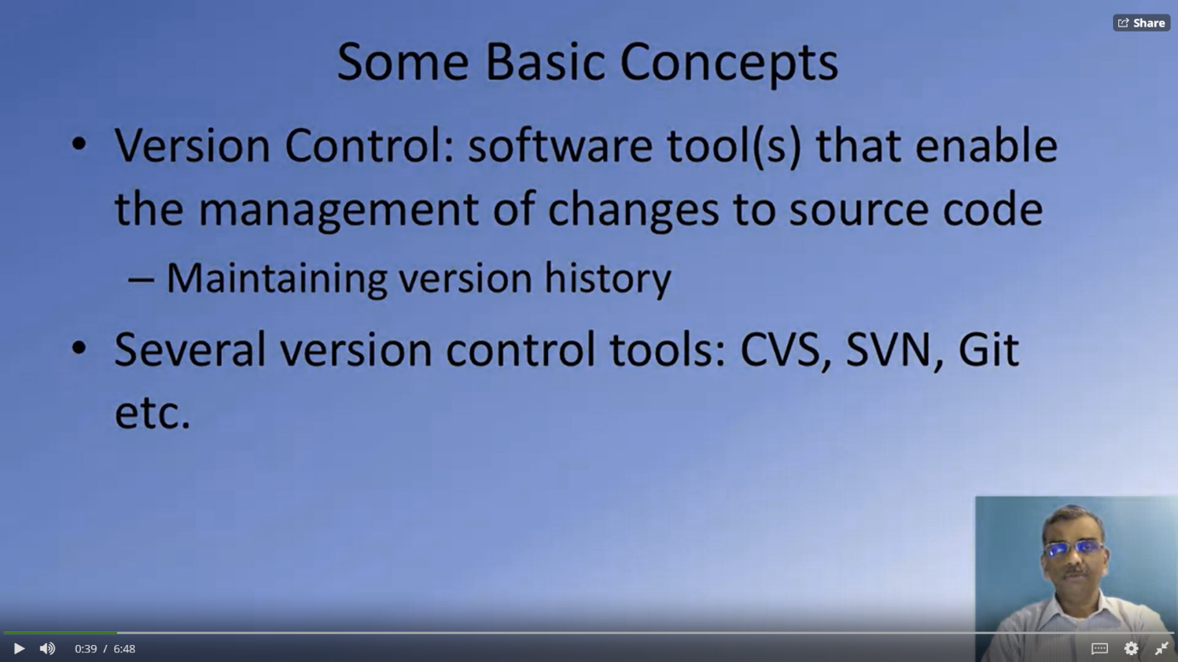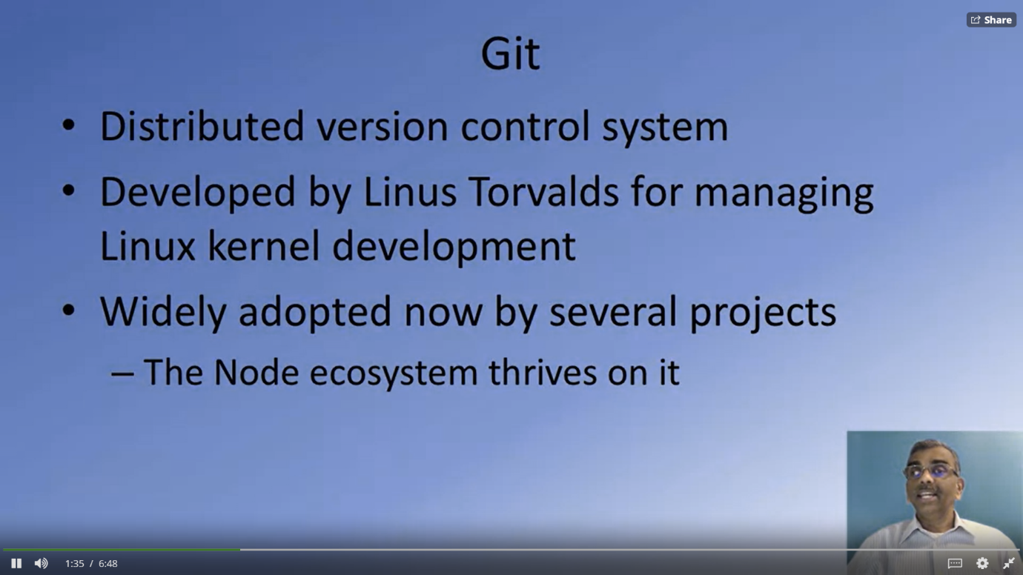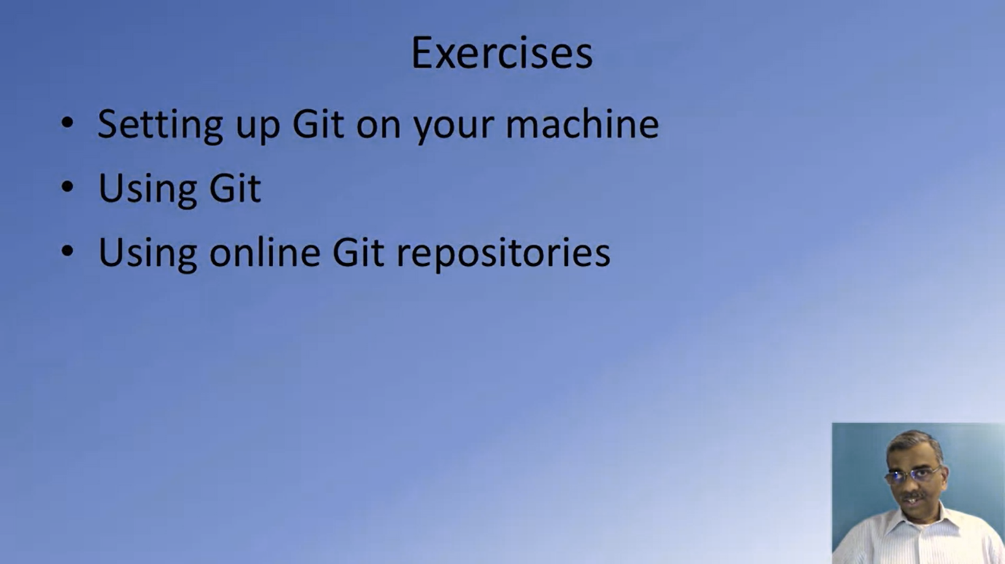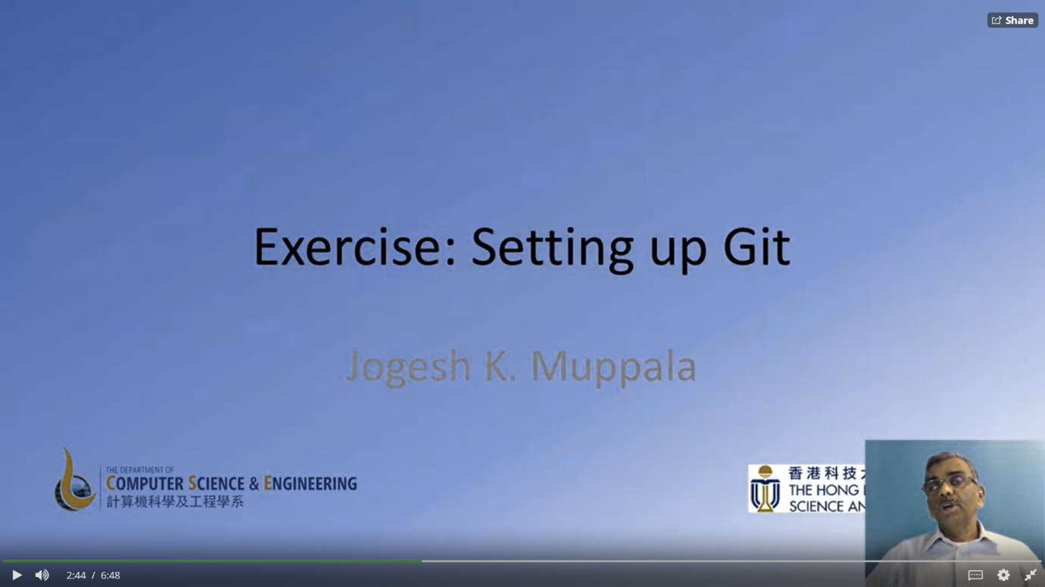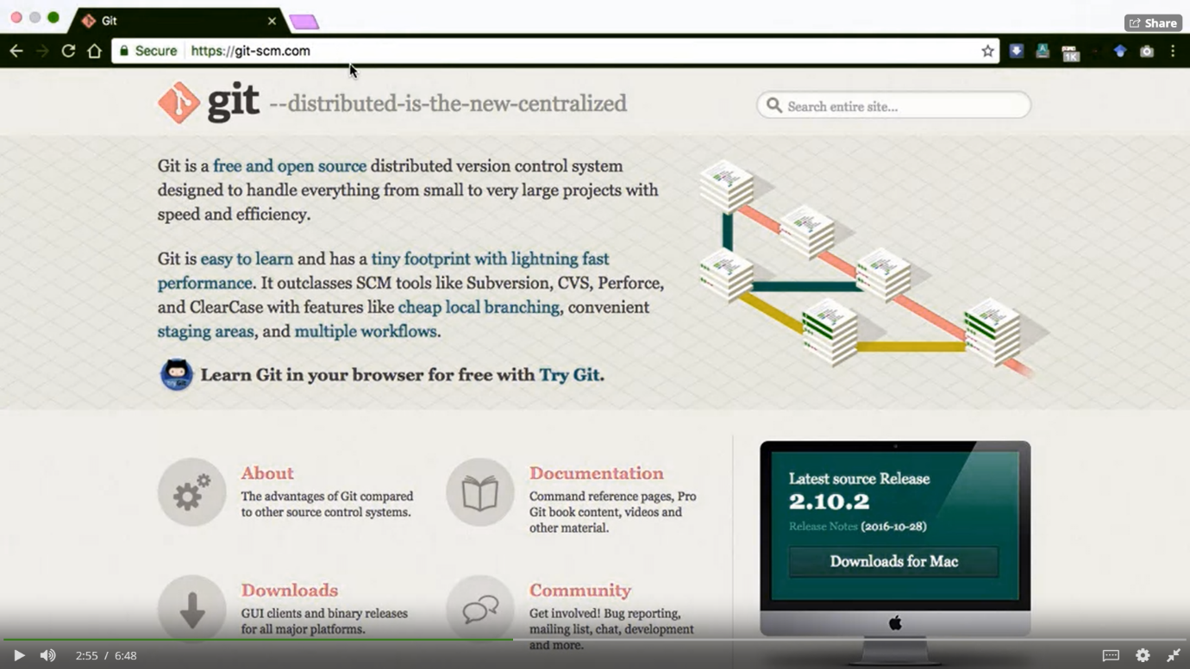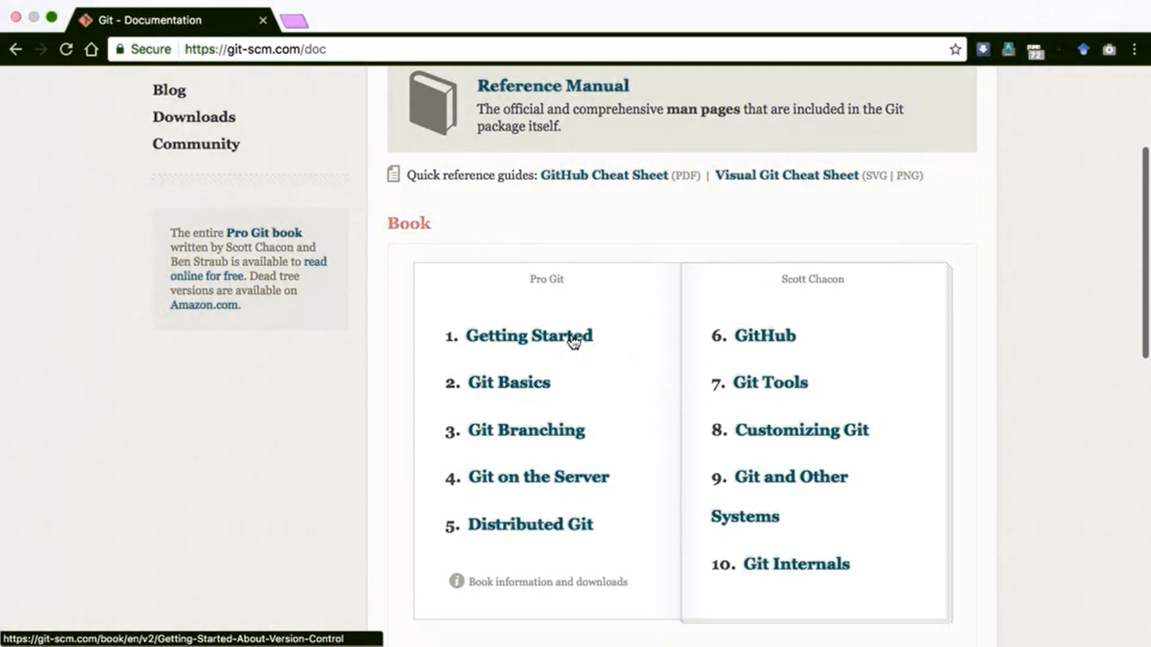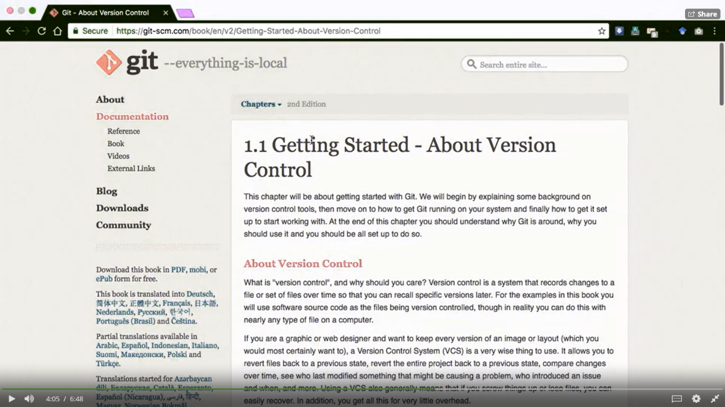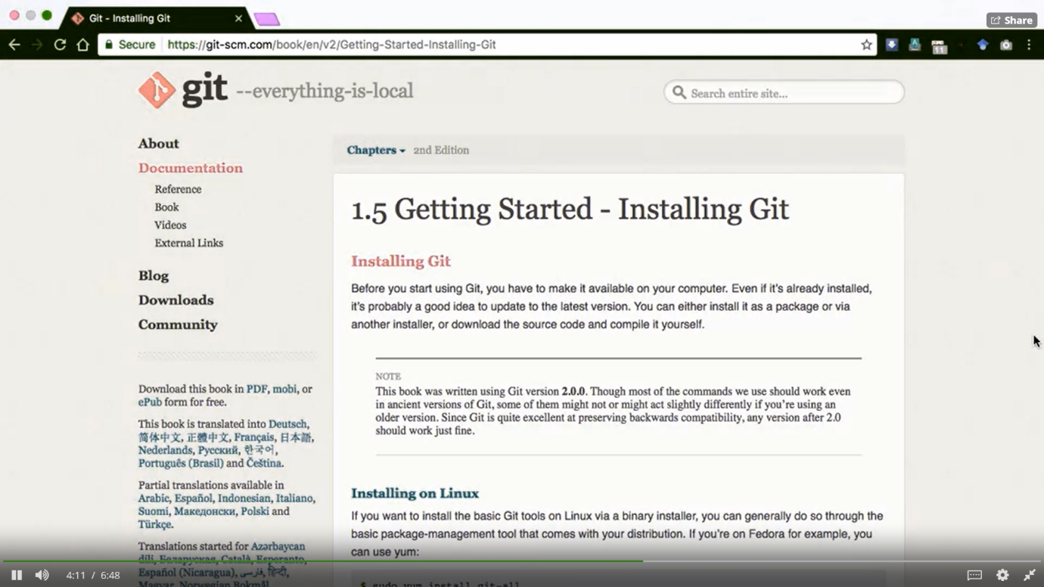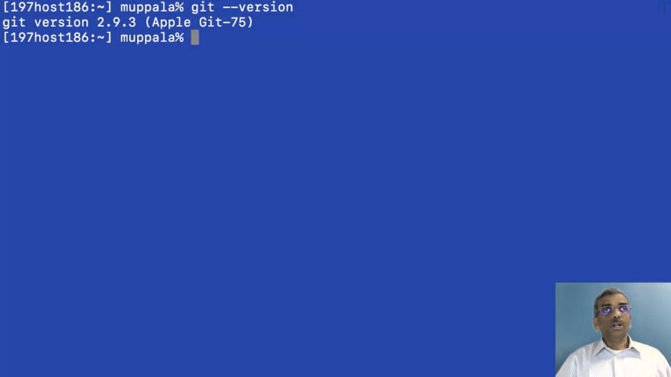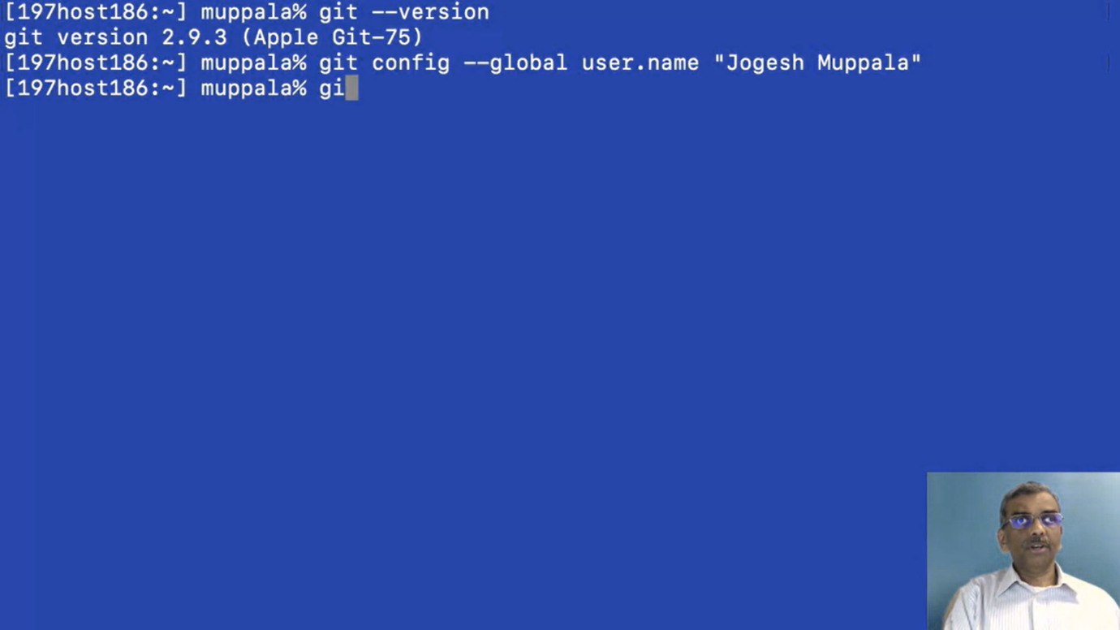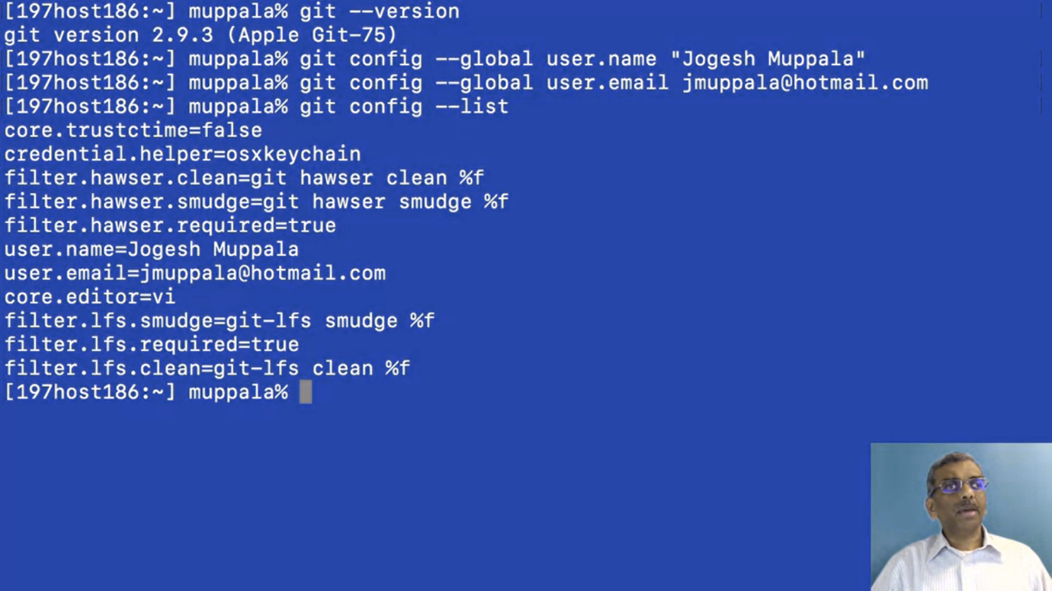

# **Exercise (Instructions): Setting up Git**

### Objectives and Outcomes

In this exercise you will learn to install Git on your computer. Git is required for using all the remaining Node.js and Node based tools that we encounter in the rest of the course. At the end of this exercise, you would be able to:

* Install Git on your computer
* Ensure that Git can be used from the command-line or command-prompt on your computer
* Set up some of the basic global configuration for Git

### Downloading and Installing Git

* To install Git on your computer, go to <https://git-scm.com/downloads> to download the Git installer for your specific computing platform.
* Then, follow the installation steps as you install Git using the installer.
* You can find more details about installing Git at <https://git-scm.com/book/en/v2/Getting-Started-Installing-Git>. This document lists several ways of installing Git on various platforms.
* Installing some of the GUI tools like GitHub Desktop will also install Git on your computer.
* On a Mac, setting up XCode command-line tools also will set up Git on your computer.
* You can choose any of the methods that is most convenient for you.

Some Global Configuration for Git

* Open a cmd window or terminal on your computer.
* Check to make sure that Git is installed and available on the command line, by typing the following at the command prompt:

git --version

* To configure your user name to be used by Git, type the following at the prompt:

git config --global user.name "Your Name"

* To configure your email to be used by Git, type the following at the prompt:

git config --global user.email <your email address>

* You can check your default Git global configuration, you can type the following at the prompt:

git config –list

There is lot more to Git than what we cover in this exercise.To get started go to your convenient location on your computer and then create a folder named git-test.

Then, open this folder in your favorite editor.Here, I have the

GIT-TEST

folder that we just created open in my Visual Studio Code. Let me add a file to this folder named

index.html,

now you can see that I have added in some HTML code into this index.html file.

Let's save the changes. Now let's switch to our command line,at the command line go to the git-test folder, and

let's initialize this folder to be a git repository. So to do that at the command line type

git init

.Now, this folder has been initialized to be a git repository.So this is our first git command that we have learnt,

git init. This initializes the current folder as a git repository and when it initializes the folder, it will mark that folder as a master. This is the master branch for my kit.

Now let's not worry about branches and so on, we will not deal with that in this course.

We will only be working with the master branch, in this particular specialization.

So this would be marked as a master. Now this is the initial point of our repository.

The next command that we're going to look at is

git status.

If you type git status in the command line, it'll tell you the current status of the folder.

So let's do that at the command line and see what it shows.At the command line, type git status and read the information that is tapped out on the command window.

You see that it says on branch master, so that is the master branch that we add on.

And it says,

untracked files, and then shows index.html in red.

On your specific computer, it may be using different colors or represent this differently or this is what it shows on my Mac.

So now, this index.html file that we have just created in this folder is now not been added to our git repository.

So let's go ahead and

add that file to the git repository.

So to do that, we say,

git add .

, and you can simply say dot, which means that all the files in the current directory will be added to what is called as the staging area of my git repository.

So now, if I again type

git status,

you will see that the file index.html is marked in green. And it says, changes to be committed there and then shows the file name and then so

that means that this file is now ready to be committed to my git repository.

So, the next command that we saw was

git add

. By using git add you can add file or folders to that staging area.

So once you add it to the staging area, then you can commit that snapshot

of our folder status to our git repository. So that means that when you do the git commit,what this command will do is commit the current

state of our folders into our git repositories. So all the files as they exist at the moment,

once they have been staged using the git add, then they will be committed to our

git repository when we execute the git command folder.

So at this point when we execute the git command, then our initial

state will now be changed to the first commit to the git repository.

So let's go ahead and do that.Back at the command prompt, let's type git commit.

And then we can even add a message to our commit.

So I'm going to say

git commit -m "first commit"

because this is our commit to our git repository. So when I do that, it says, okay, 1 file has been added to the git repository and some other information will be typed out on to the command window.

So let's now check again, git status and now you see that it says nothing to commit, working directory is clean.

So what it means is that the current state of my working directory or working folder has been committed to the git repository, so a snapshot has been committed to my git repository.

Now, I can type the next command called

git log --oneline,

and see that it shows a number there, an

eight digit

number there, and then also it shows the message that we put into our commit saying first commit. So that is the log of all the commits that have been put into my git repository.

So, going back to our next git command,

we saw that

git log --oneline

will show us a brief log of all the commits. If you simply type

git log

display a lot more detailed information about all the commits. But this is sufficient enough for obtaining information that we require.

Let's now come back to our editor here, in Visual Studio Code, so I'm going to add more changes to my index.html file.

I have changed my index.html file. Now, let me add another folder under the

git test folder

, so I will create a subfolder here named templates, and inside these

templates folder, I'm going to create another file name, test.html. This is just to show you how git can commit entire folder hierarchy into its repository.

So with test.html now there, I'm just going to copy everything from my index.html

into my test.html, and save the changes.

Going back to the command line, let's now check out the status of our git repository and this folder. So type in git status, shows that the index status html file that we have already handed earlier to the repository has now been modified, so there is a newer version of the index.html file.

Also, it shows that there are some untracked files in this folder called templates.

Let's add all these changes to the staging the area, so again, type git add.

And then all these files will be added to the staging area. Again, checking out the status.

You now see that changes that have been added to the staging area. So all these files have been added to the staging area.

Let's do one more commit, so I would say git commit -m, second commit and

then let's check out the log.

If you check out the log, you'll now see that there are two commits

in my git repository, the first and the second commit. And note that each one of them is given a different number there. If you want to see their full details of the log,

you can type simply, git log and then you'll receive more details in there.

Then what you would be interested in. So, notice that the oneline commit only gives the first few characters of my commit number there. That is sufficient enough for us to operate with.

Let me now go back again to my Visual Studio, and then add one more.One more line to my index.html file. So now my index.html file has been modified.And let's save the changes.Going back to the command line, doing gitstatus shows that index.html file has been modified.

So let's add this to the staging area, and then do a third commit. So let's say, git add.,

git status, now you see that the index.html the modified version has been added.

Now we can say git commit."third commit" and do git log --oneline,

and you see there are three commits in our repository. So now our repository contains snapshots of three different points, at the end of the first commit, at the end of the second commit, and at the end of the third commit.

Now, we also can roll back changes, we can revert the repository to a previous version.

We can pull out a file from an older commit, and then replace the existing directory from the old commit.

So, let's see how we can operate with these things by learning a couple of more commands.

At this stage, our index.html file is in the current state. So you can notice that it has an h1 and two ps.

Let's now look at the next git command.The next git command that we are going to learn about is git checkout.

So this checkout command allows us to check out a file from a previous commit in our git repository.

So if we don't like the current file that we have in our folder and we want to go back to your previous version of the file, we can always check out the file from a previous commit or

from the current commit and then continue to work with that file.

So let's make use of this and see some further changes to our git repository.

Going back to our command line, we remember that, between the second and

the third commit, I made changes to my index.html file. Suppose I want to revert back to the index.html file from my second commit.

So then, I can simply say,

git checkout 900cfcf.

So that is commit identify the number that identifies the particular commit,

and then I can say index.html, and what you would notice is that,

that older file will now be checked out into my current working directory.

Going to my Visual Studio Code,

you'll now notice that my index.html file has reverted to the previous working so,

the change that I made before the third commit it is now gone.

So my index.html file has been restored to its state at the end of the second commit.

Now, at the command line, if I try git status, you'll notice that this index.html file which was reverted to what it was at the end of the second commit, it has now already been staged.

So using this

git checkout

,

we'll pull out an older version of the file, and then replace what is in the current directory, and then it'll also check it into the staging area.

So now if I do that and then I realize that this is what I want, I can simply do another commit at this point. And then that file can be committed as the fourth commit.

But suppose I don't like this, I want to double to back to the index.html file at the end of

the third commit then all I can do is say

git reset

HEAD and index.html.So at this point, what happens is that the index.html, the modified version that I had checked out is still there but

If you go back and look at the index.html in your editor, it will still show the state at the end of the second commit.

Because we had pulled out the file using checkout for that.

Now, if you want to revert it back to what it was at the end of the third commit,

then we do one more checkout from the third commit going to our

command window, type git status and you would notice that the index.html is marked as modified.

But it also shows this particular statement here.

It says

git checkout – and the file name

, to discard the changes in the working directories. So that's one way you can discard the changes that you have made to a particular file corresponding to the previous comment.

So let me just restore that index.html back to what it was at the end of the third commit.

So to do that, I could simply say

git, checkout-- index.html

and then, if I do git status, it shows that my directory is clean. And basically my directory has been restored to the state at the end of the third commit.

Going to the file in my Virtual Studio Code, I see that their file has been restored back to what it was at the end of the third cap. So this is one way you can, if you have made changes to your file after the commit and you want to just discard those changes,

you can simply check out the file from the last commit, and then all your

changes that you've done after the last commit will be discarded on the spot.

So these are some basic commands that are very useful for you as you go through the courses in this specialization because you may want to commit at the end of each exercise.

And as you proceed forward, you would still have a guided vision of the state of your folder at the end of the previous exercise. So that way, if you're carrying out a new exercise and you've discovered that you've made mistakes and you want to revert back to the previous commit, you always have a way of doing that using the commands that we have just let.

So with this basic understanding of this few git commands, you'll be able to proceed forward with understanding and

using git in the courses of this specialization

So now, we have reviewed the git reset for a specific file or git reset in general.

If you simply type git reset, it'll restore you back to the last commit. So it will reset the staging area to the last commit,

without disturbing the changes that you have done to your working directory.

So once you reset, then you can check out the previous version of the file that you have committed in the previous commit.

So this week, you can restore your folder back to the where you were at

the starting point of the previous commit. So sometimes when you are going through an exercise and you realize you missed a cue.

Always have a way of reverting back to a previous version.

So with these commands, I think you're all set to go ahead to

use git in the courses of this specialization.

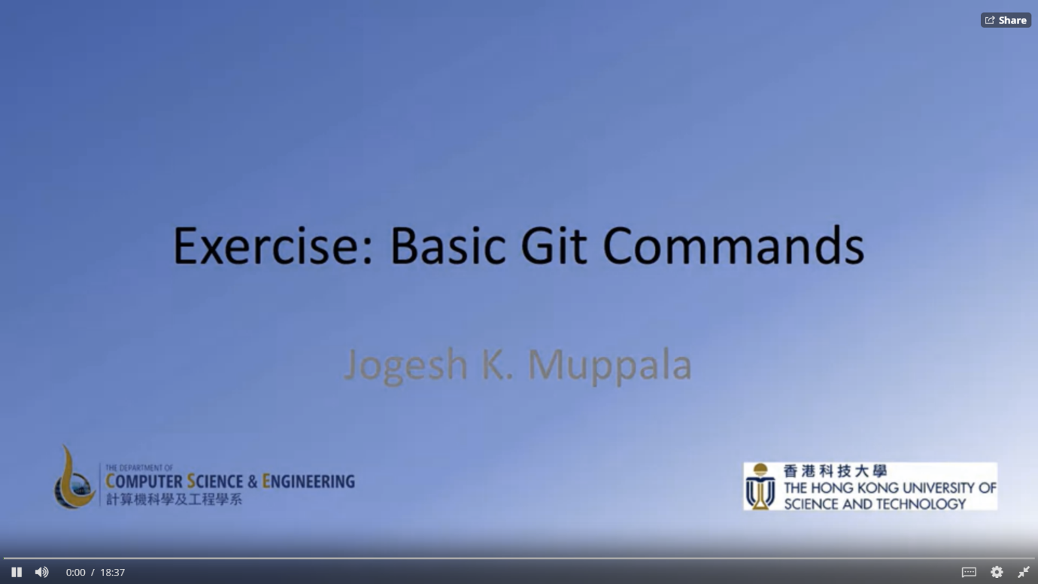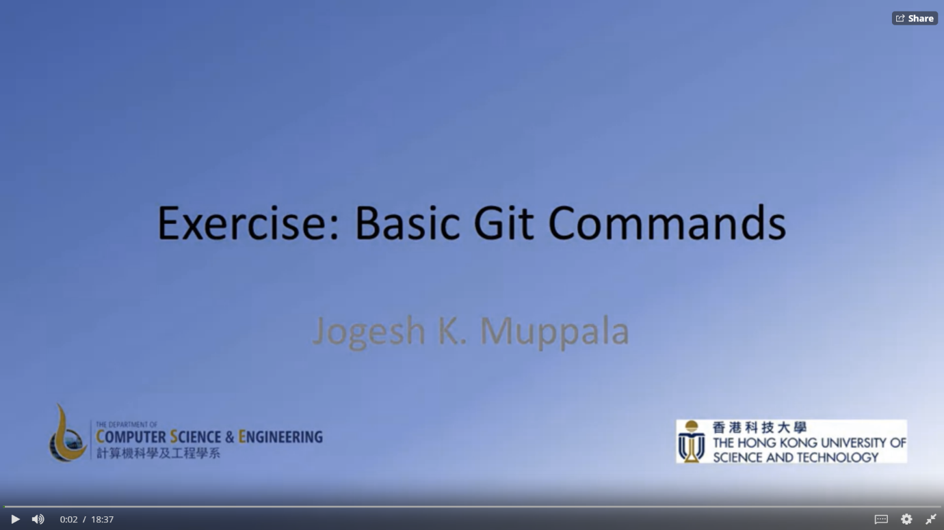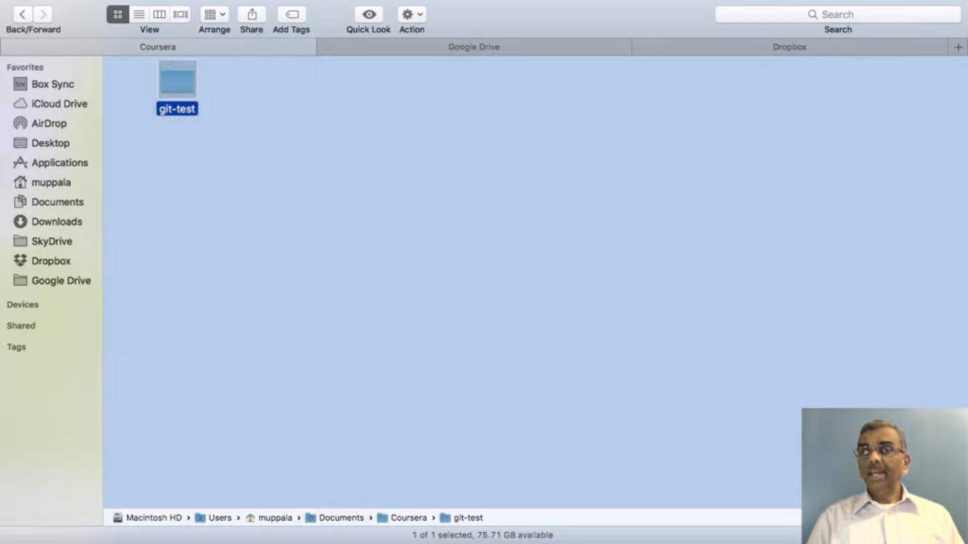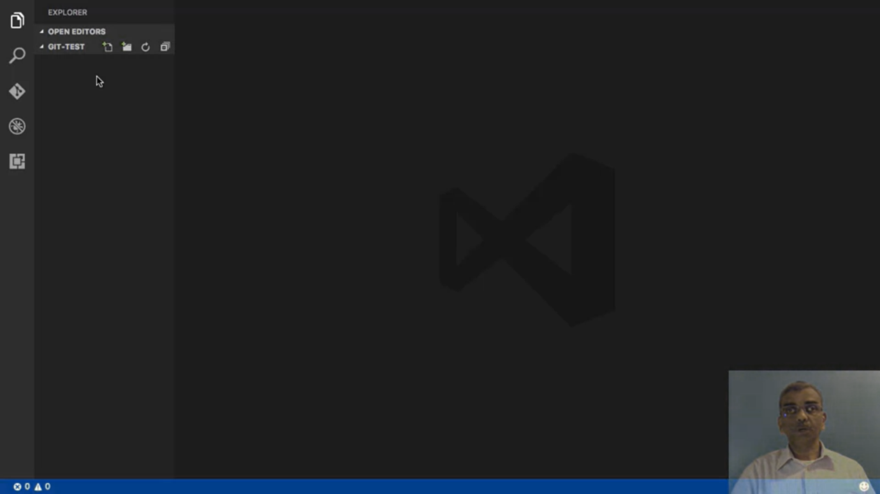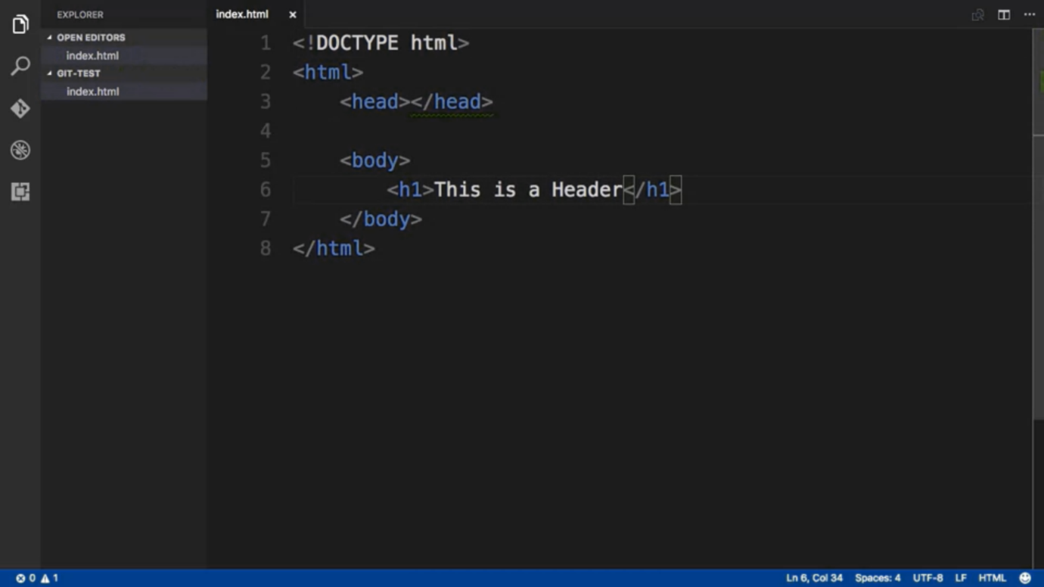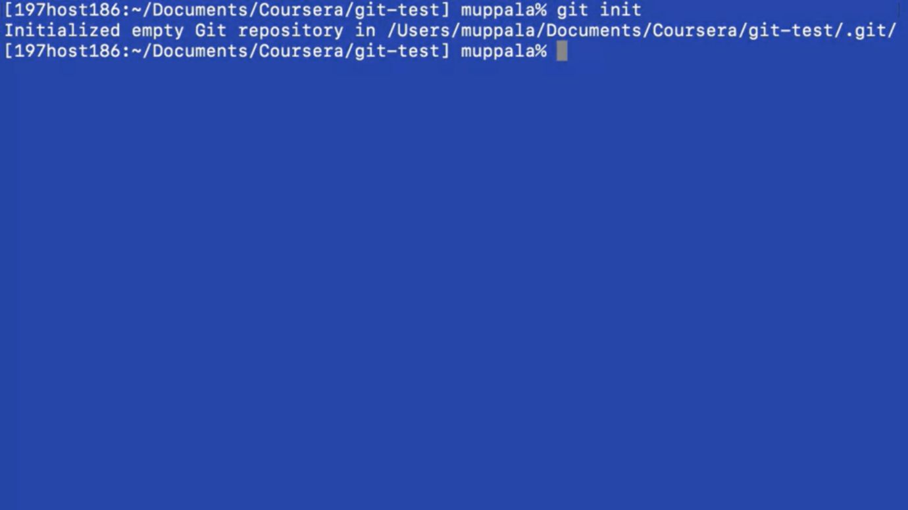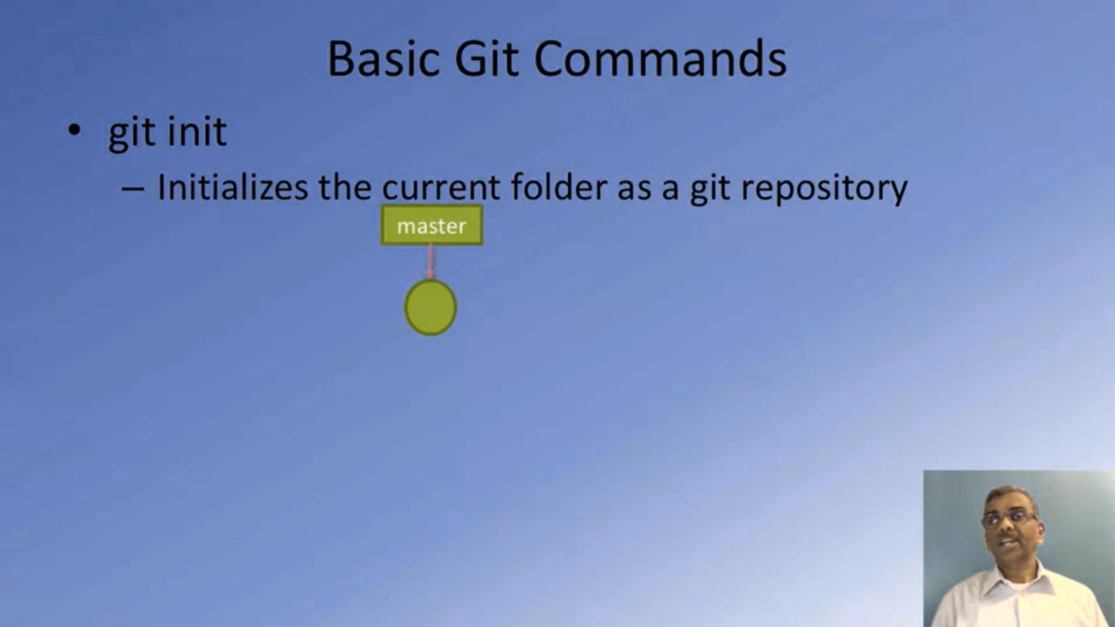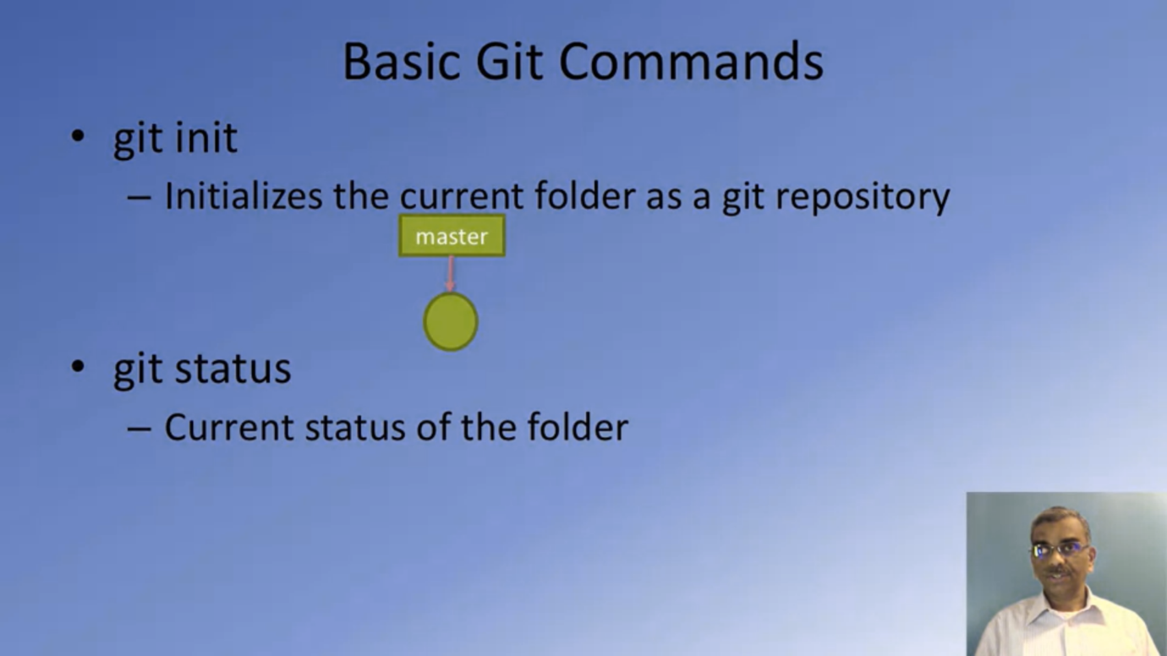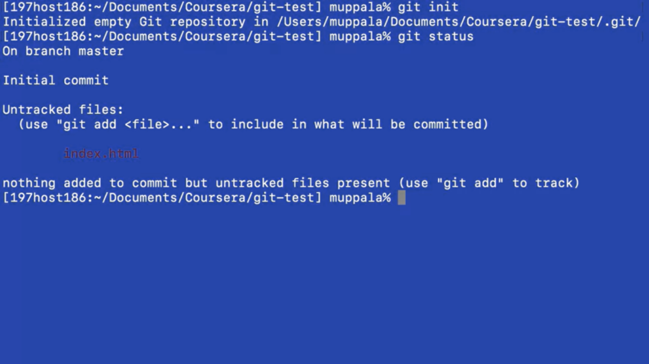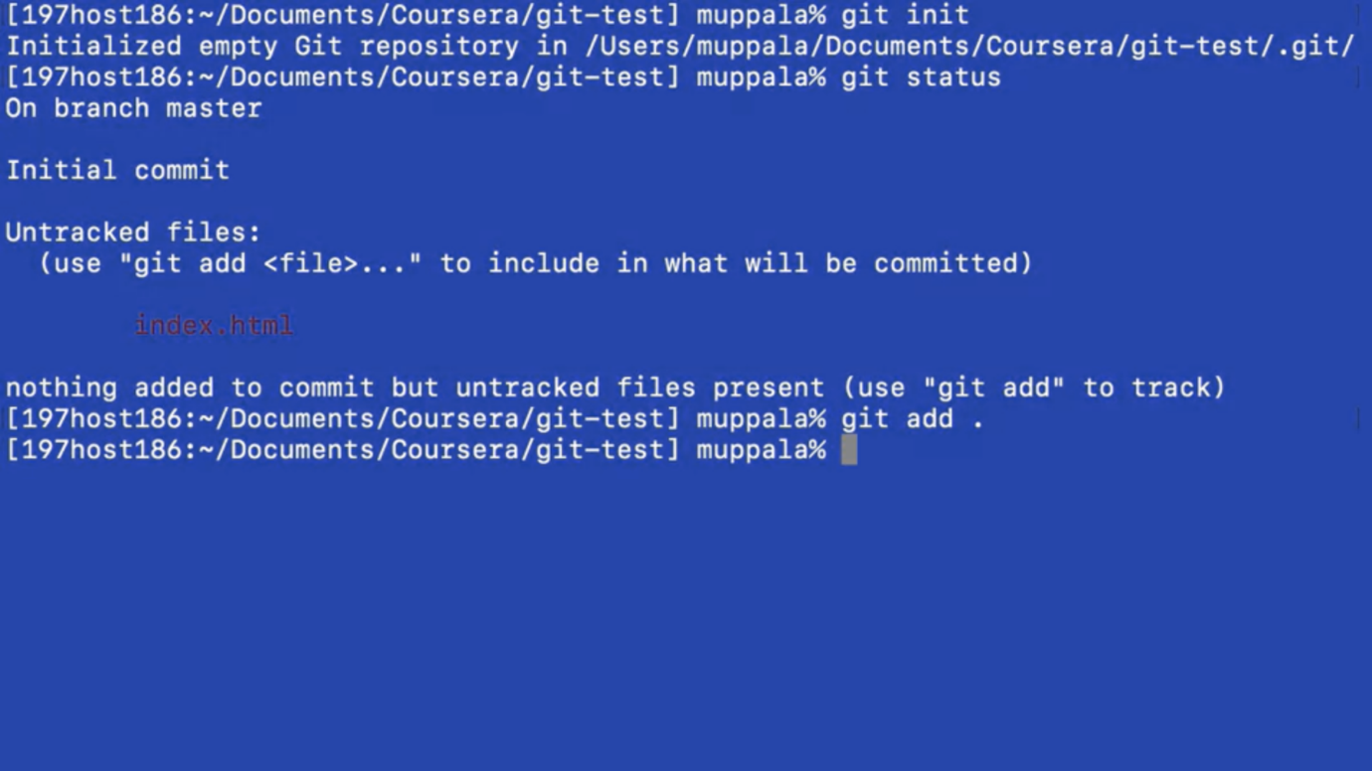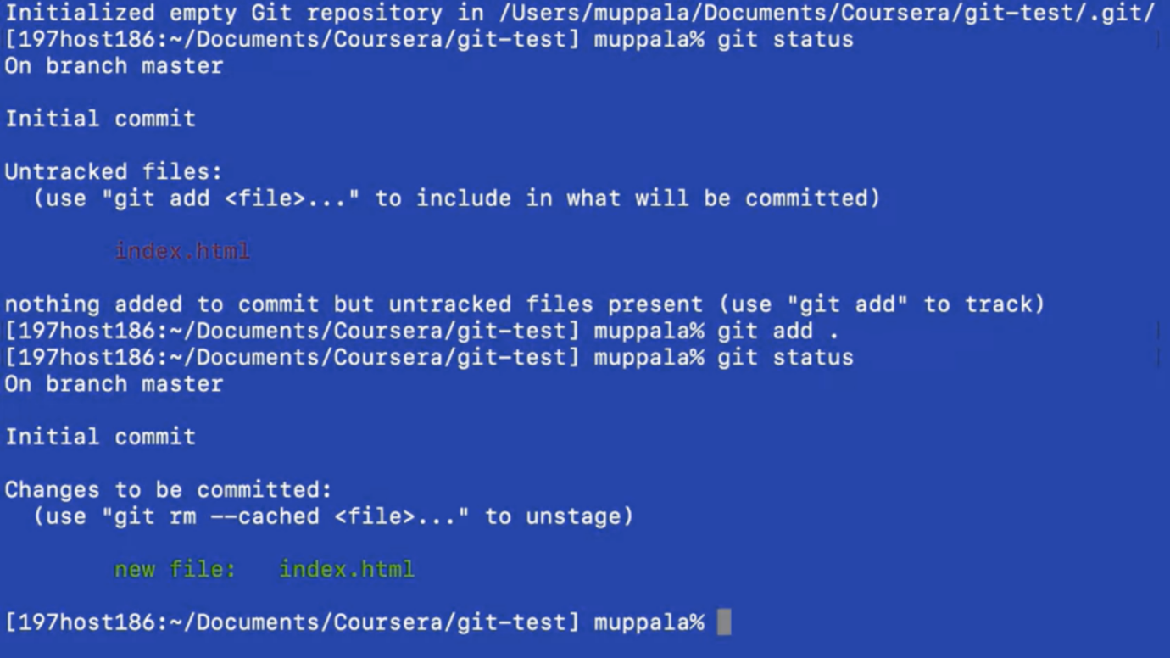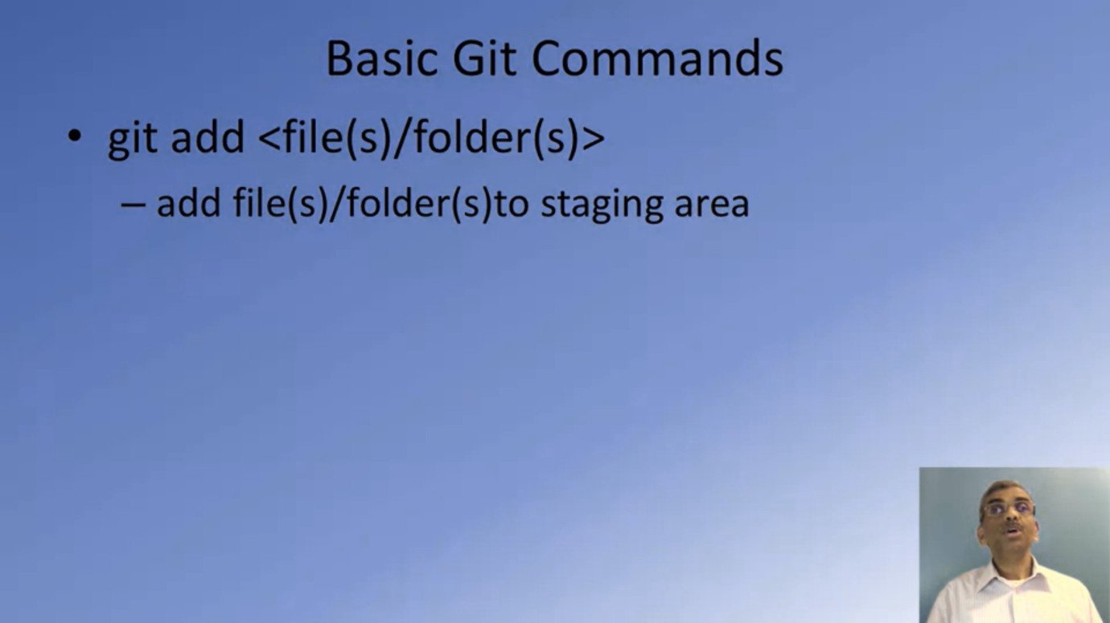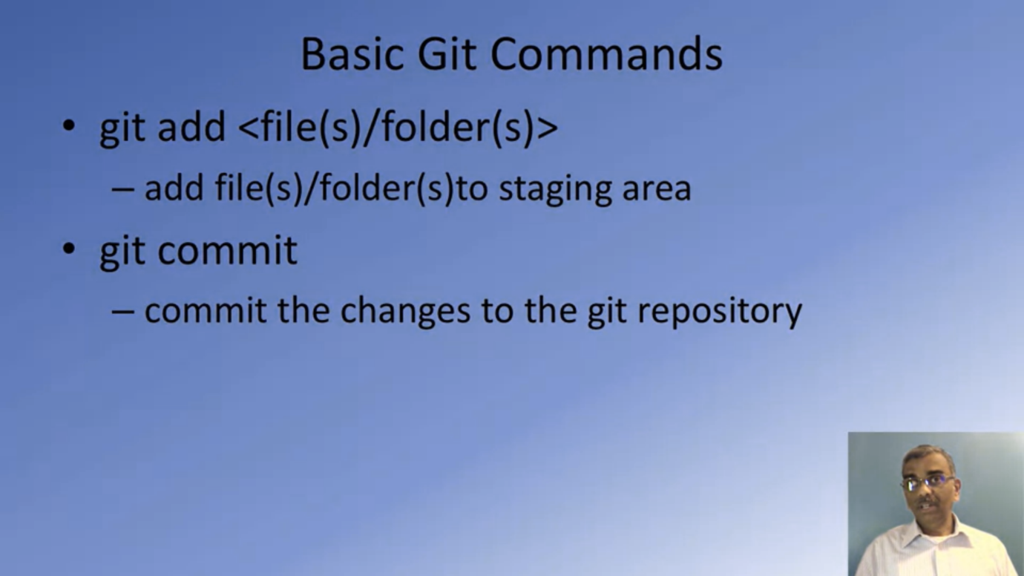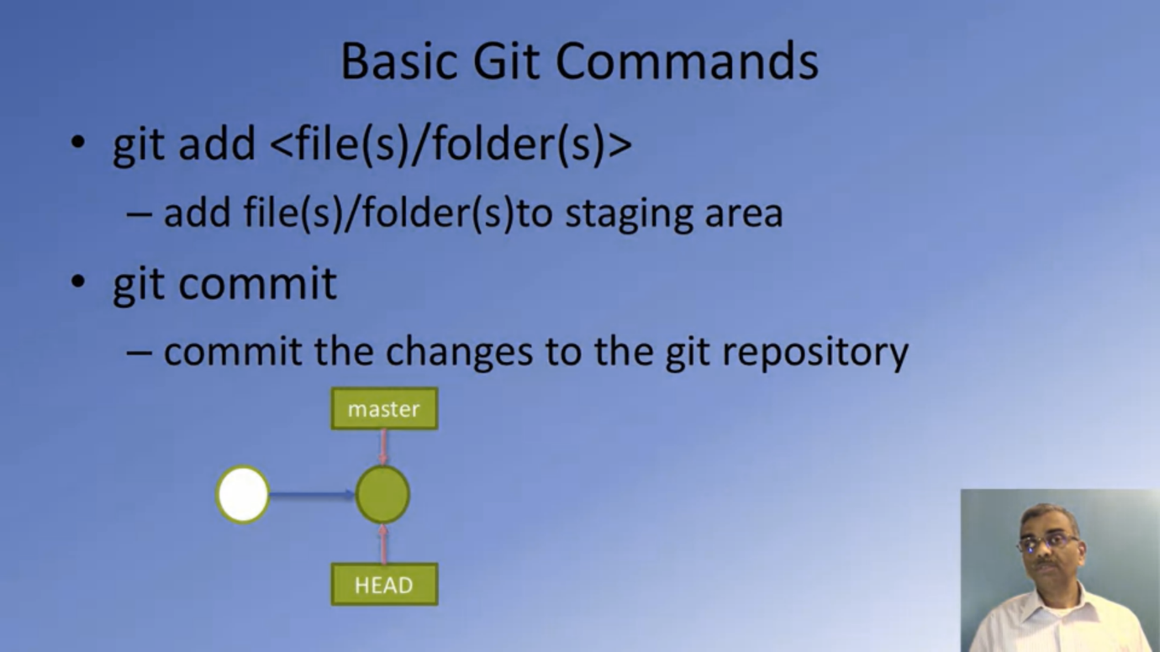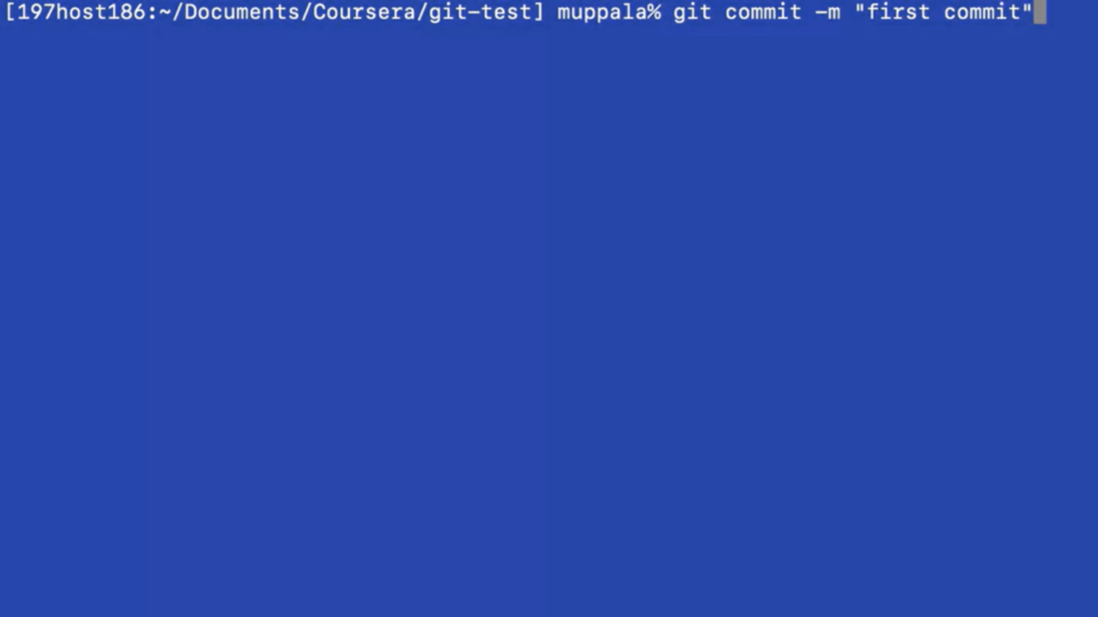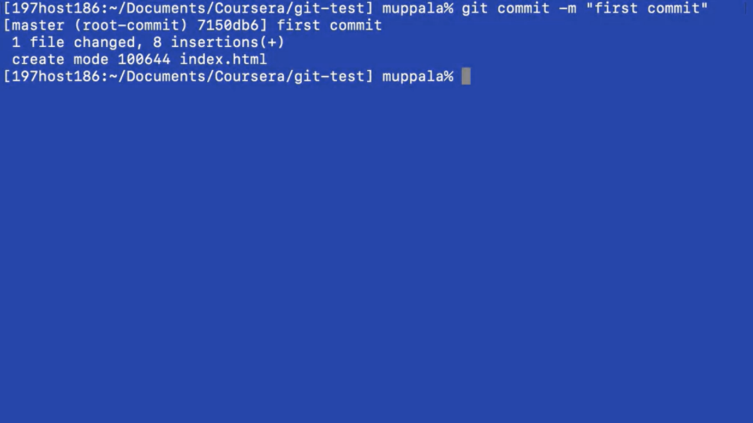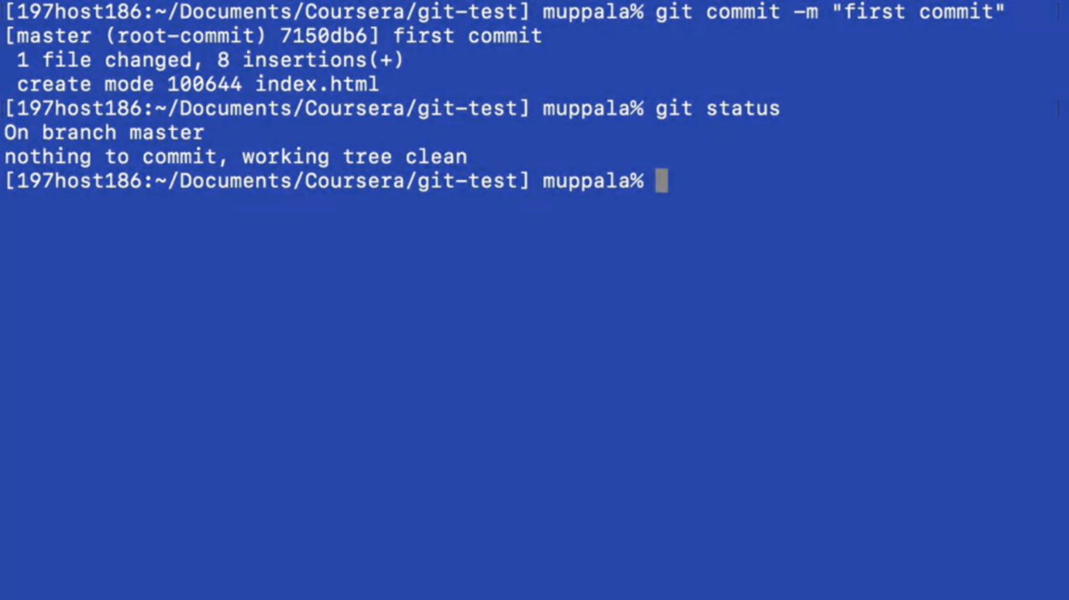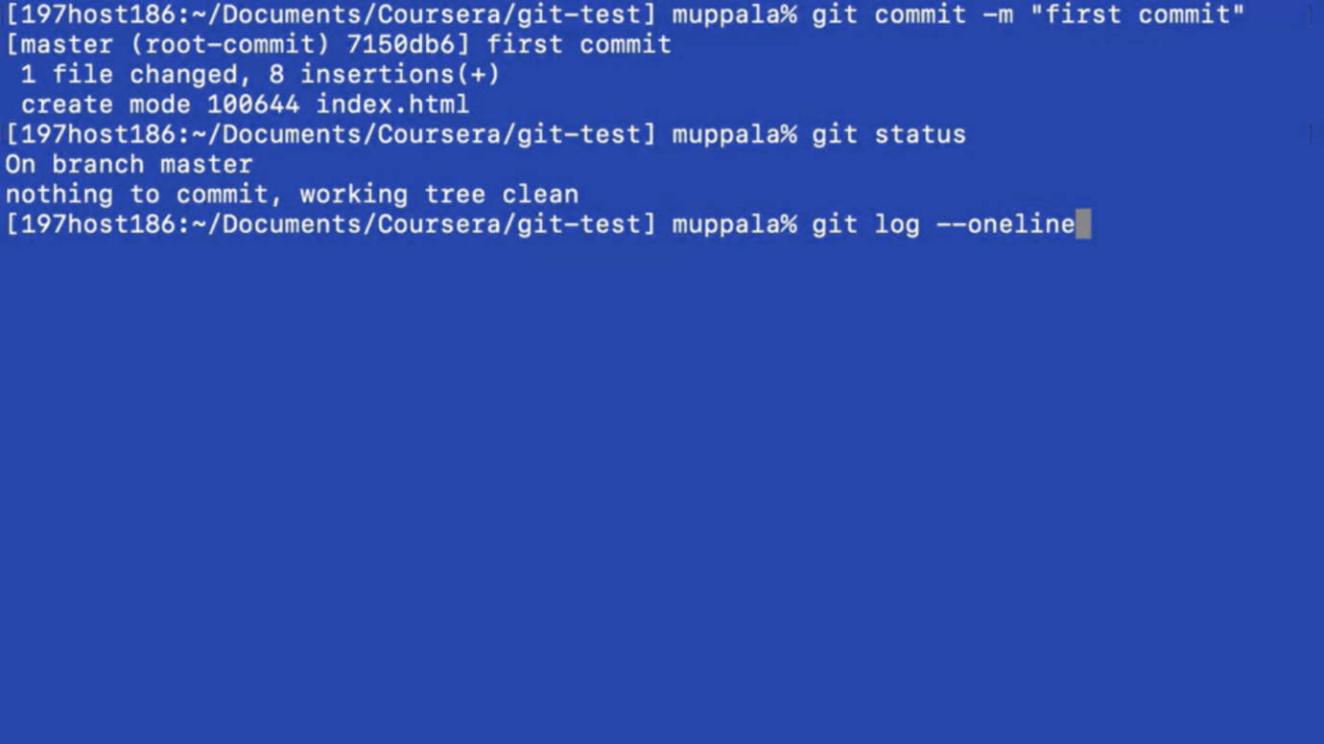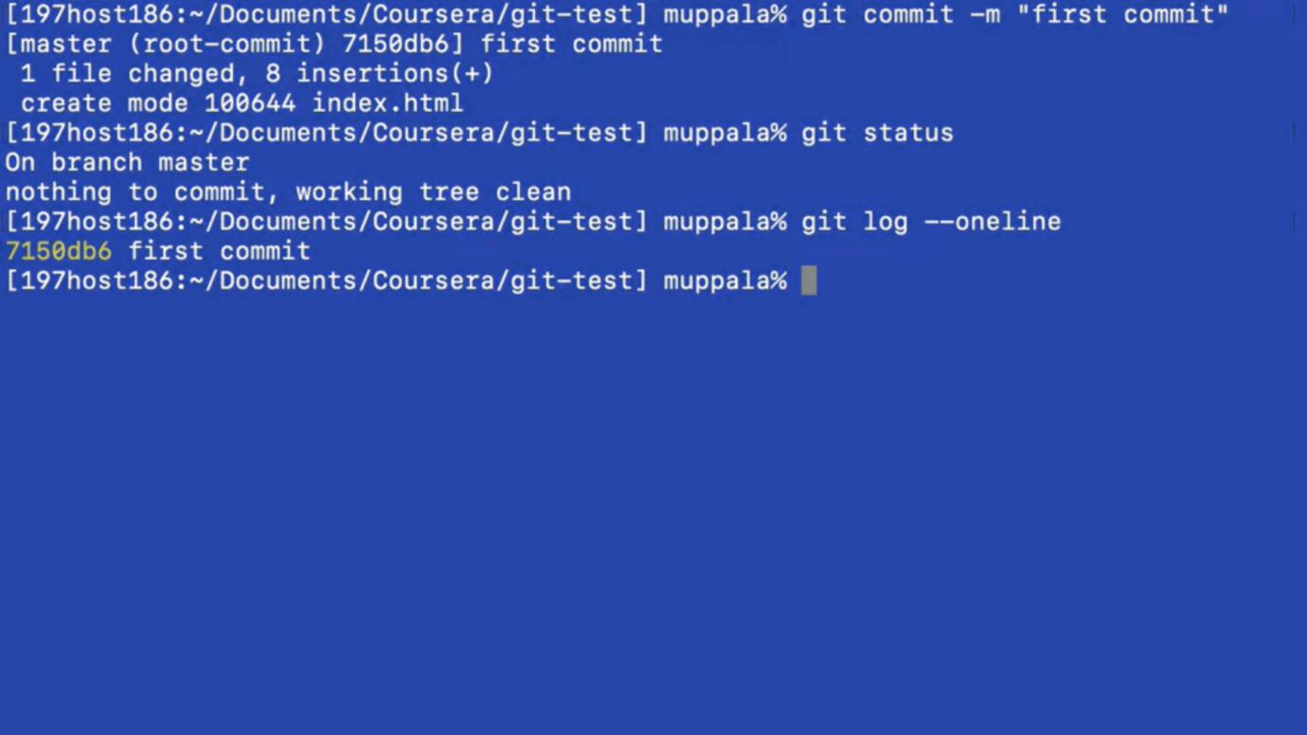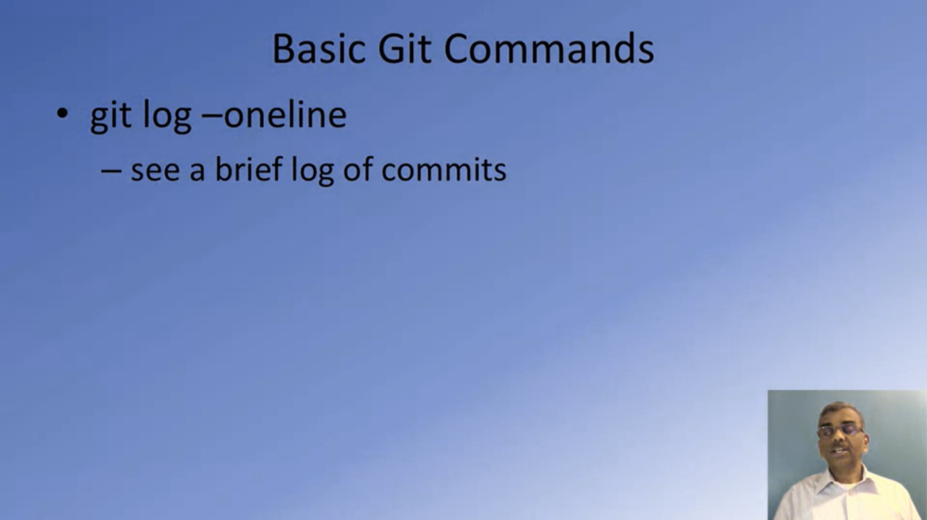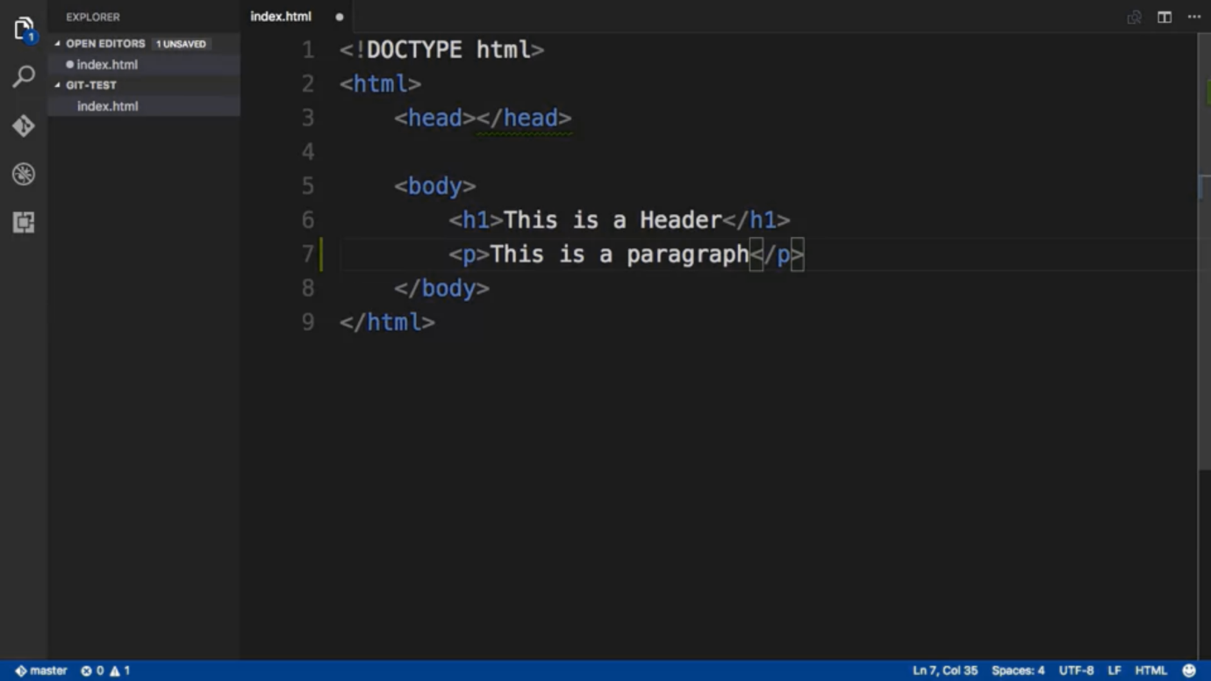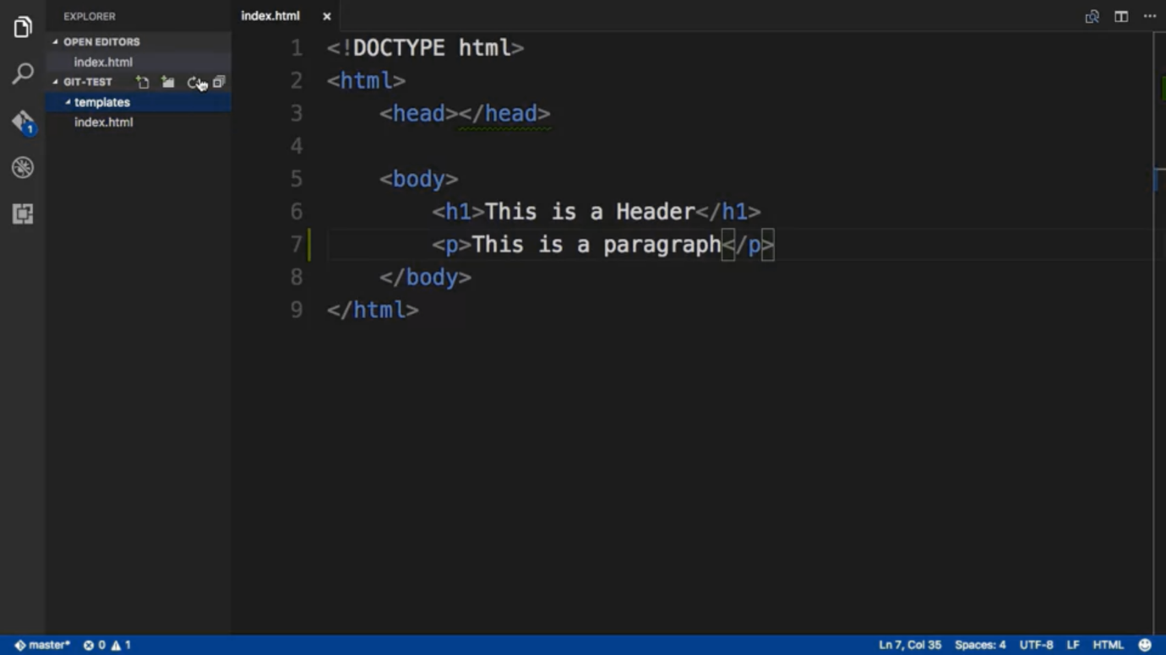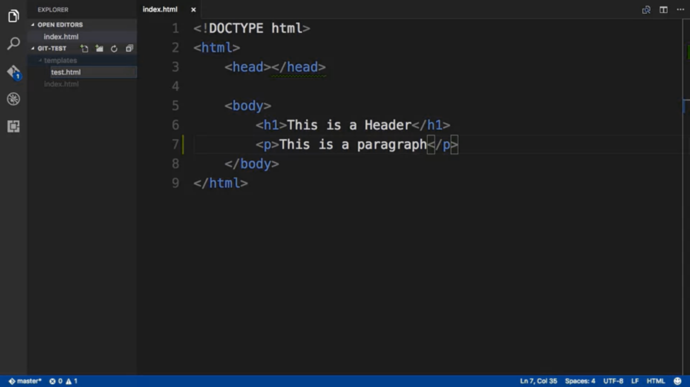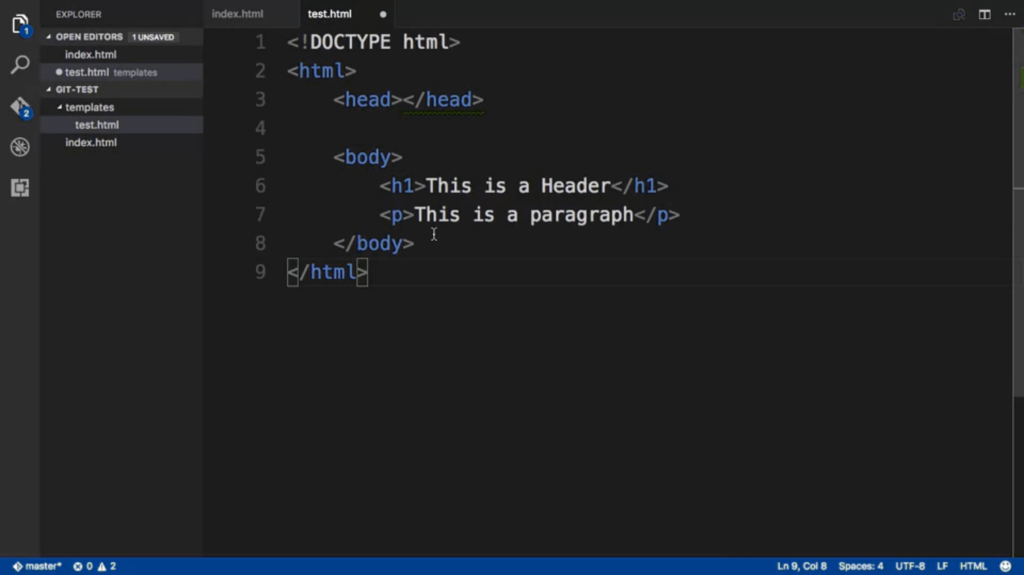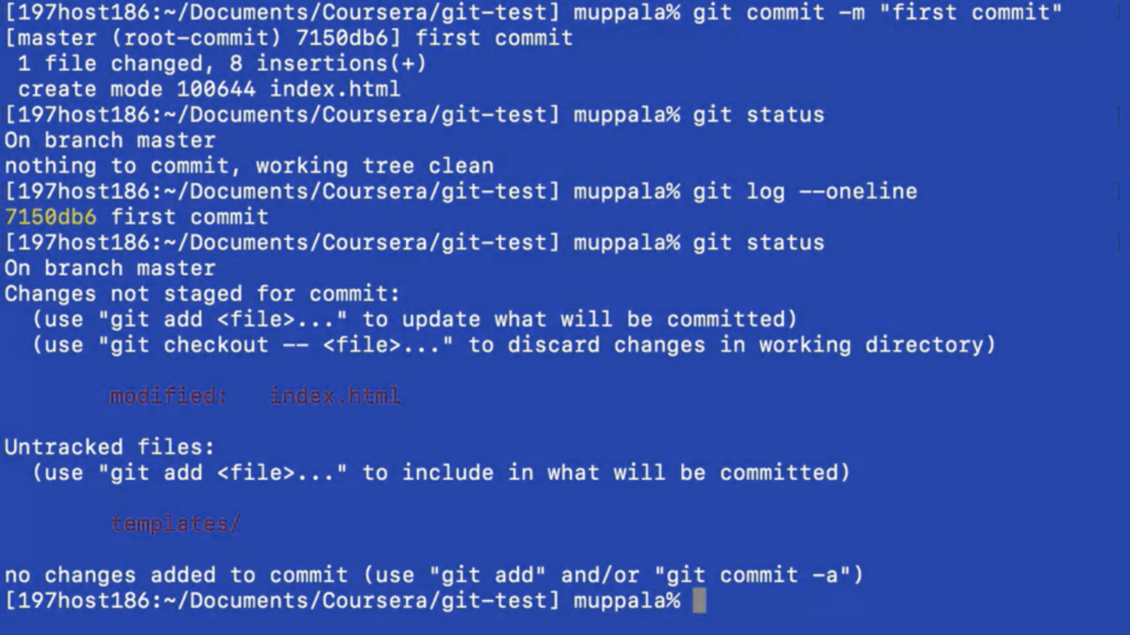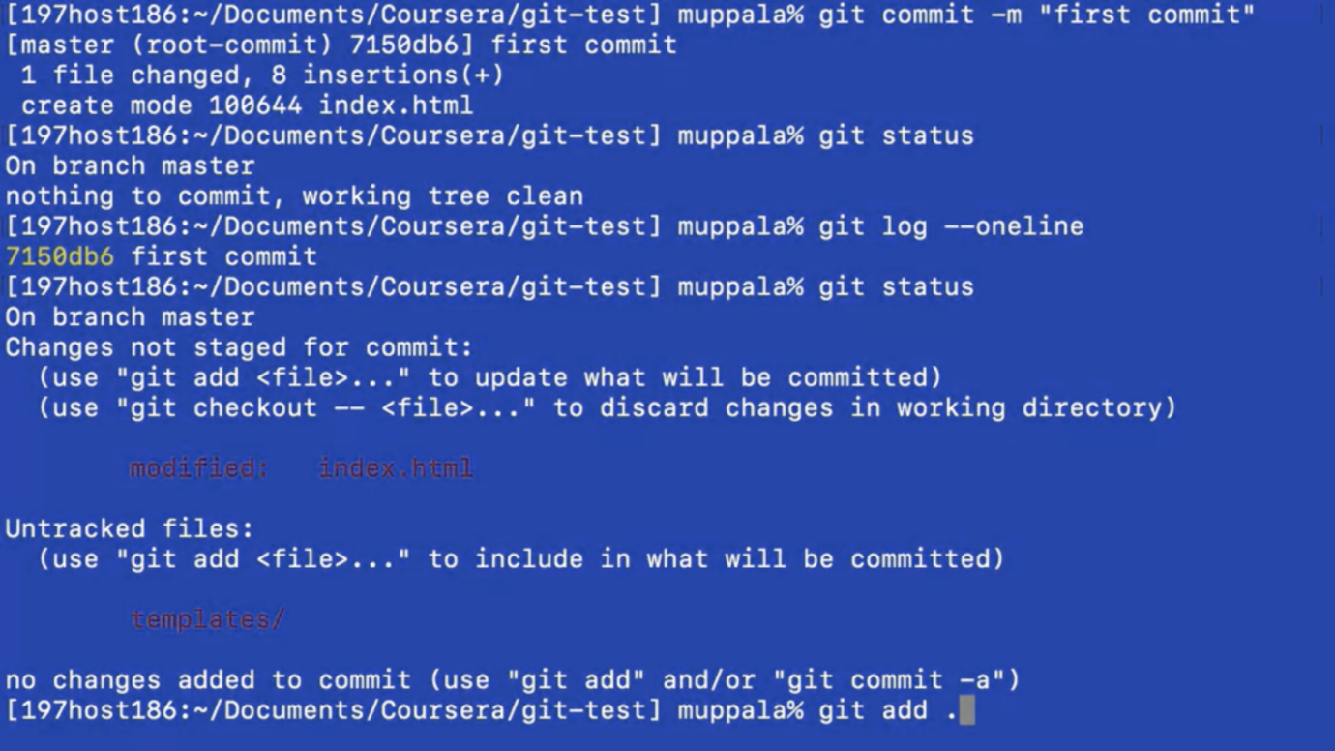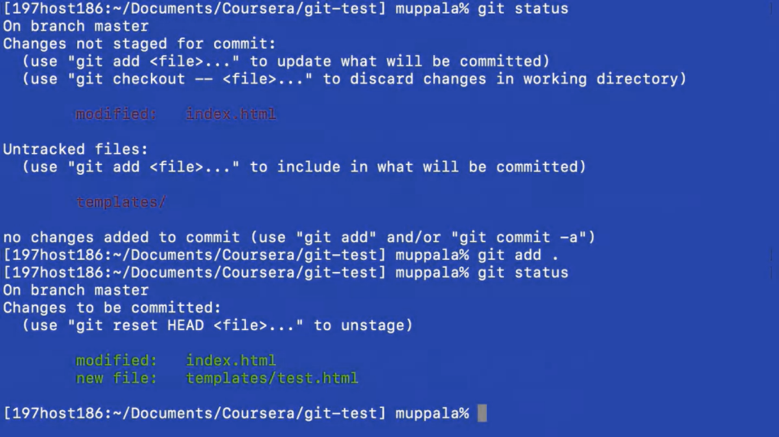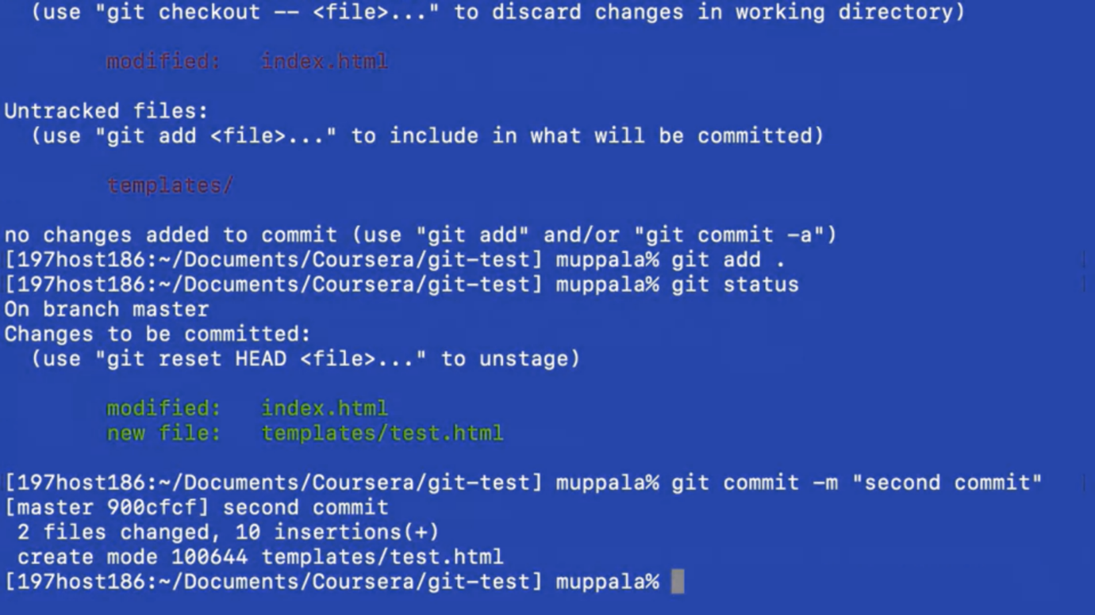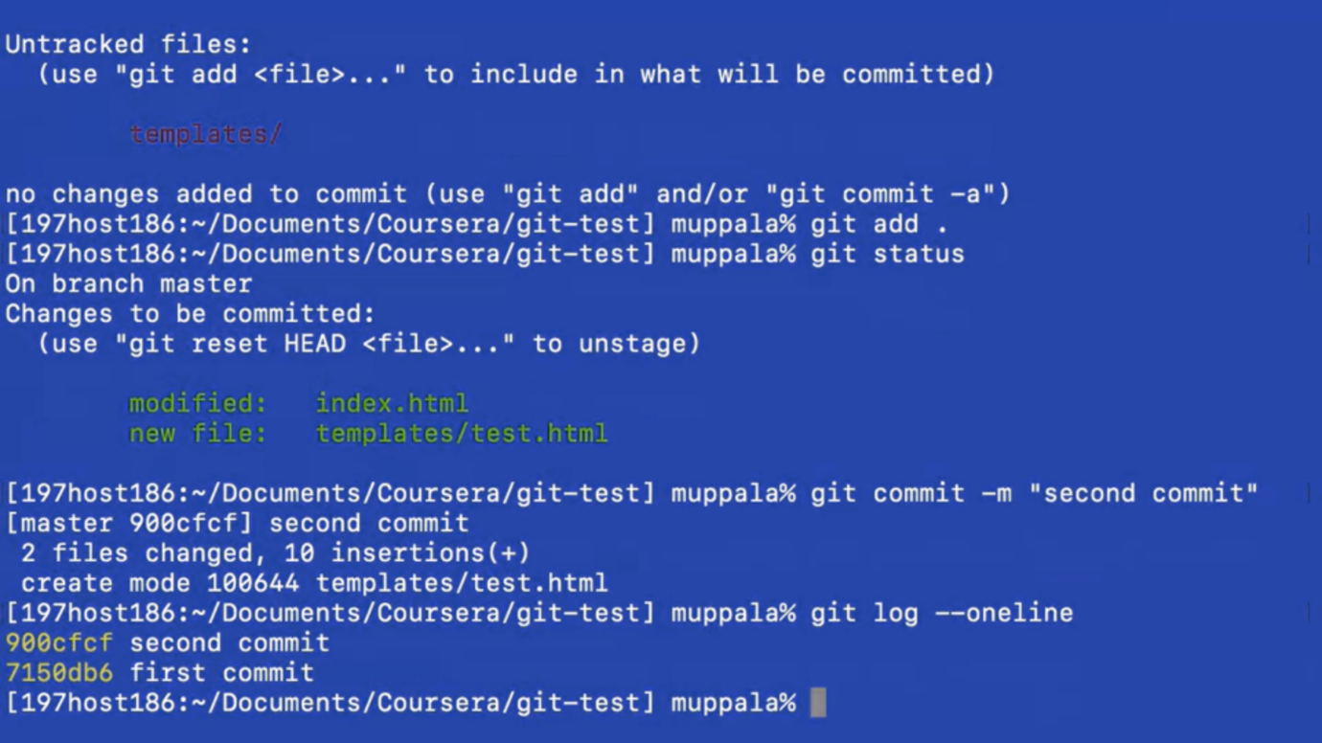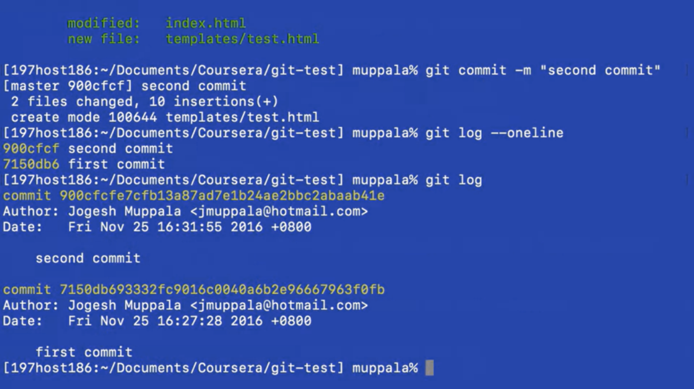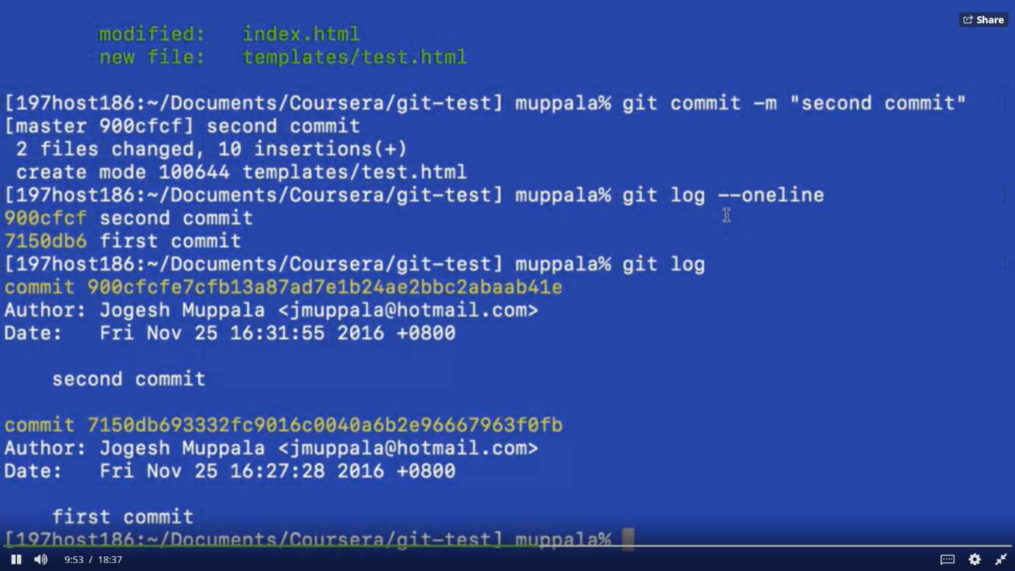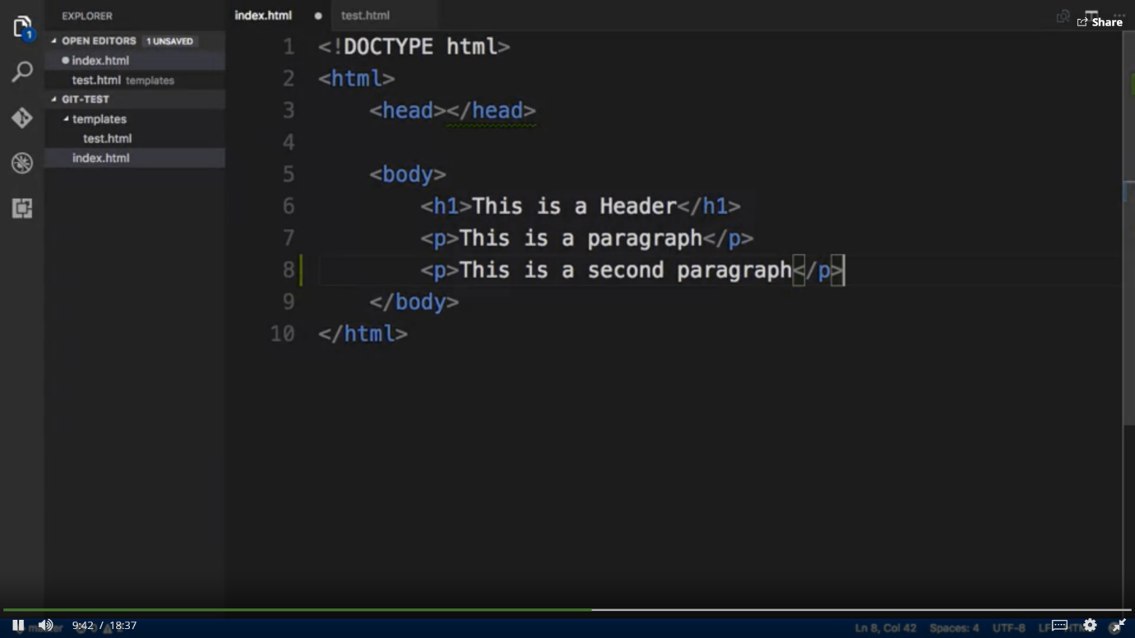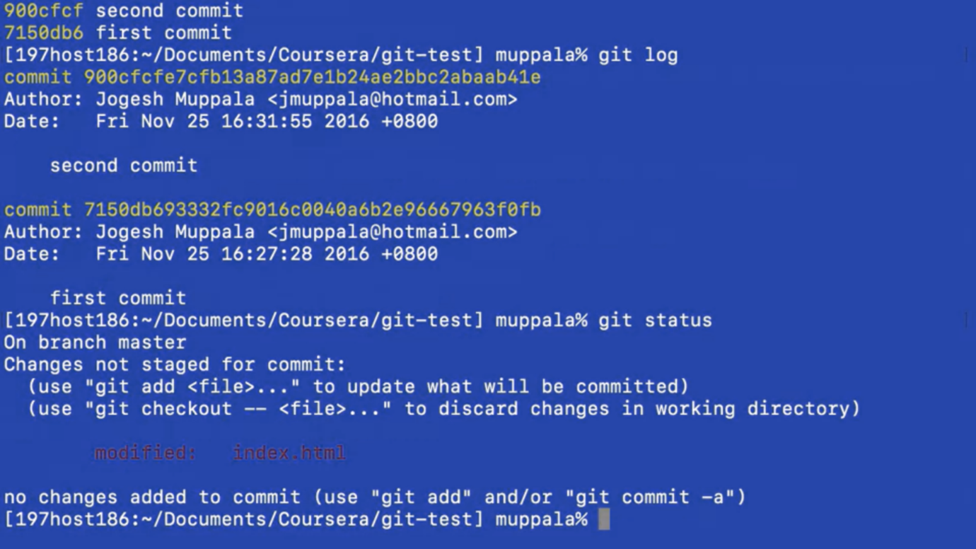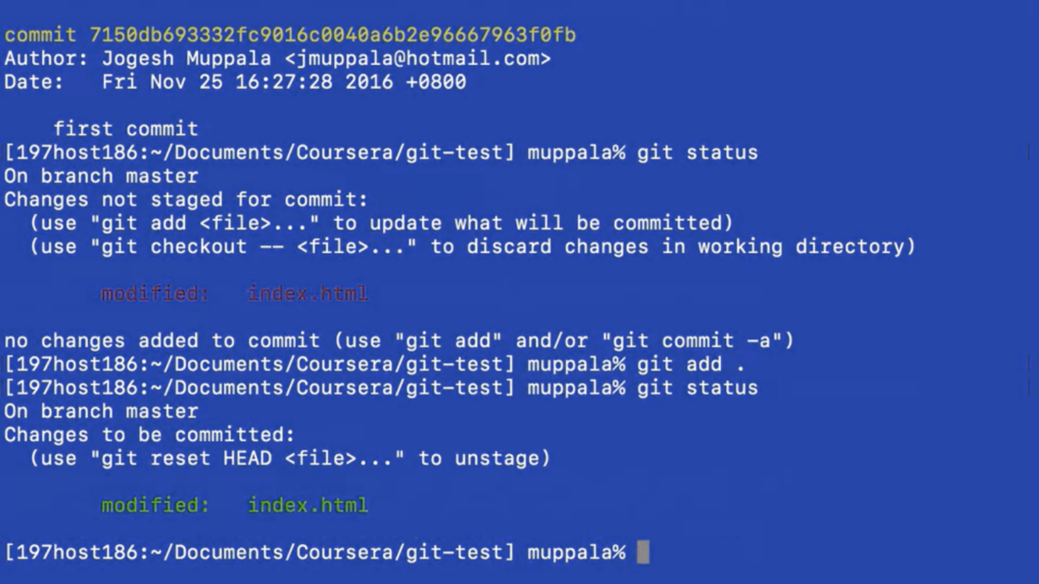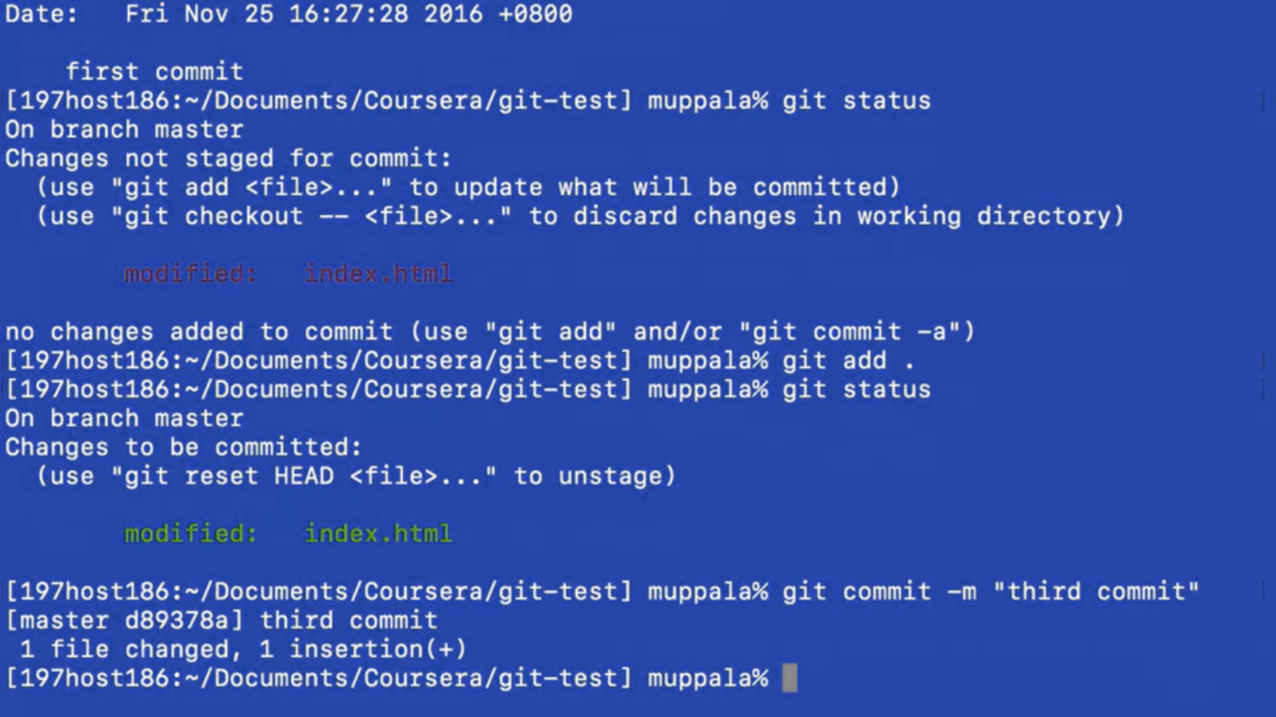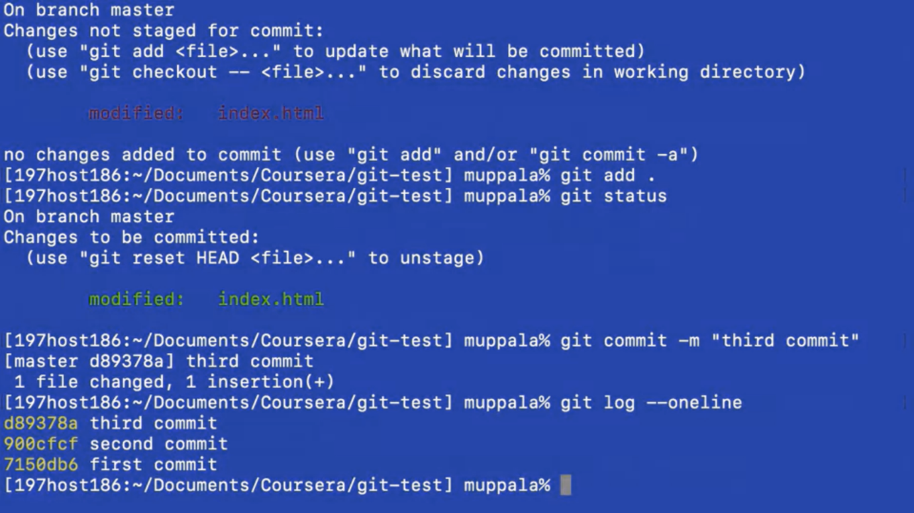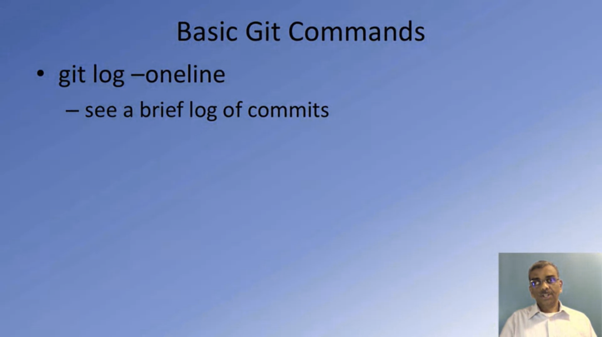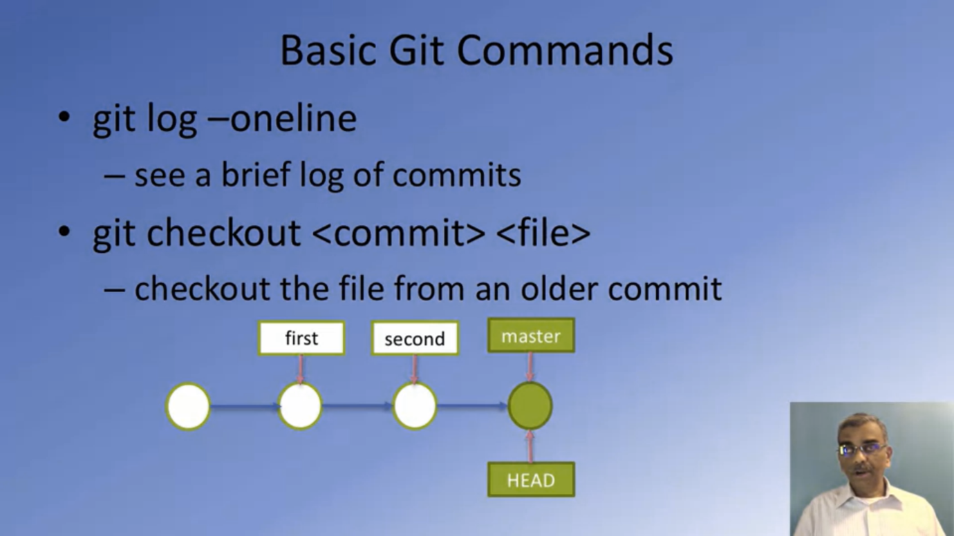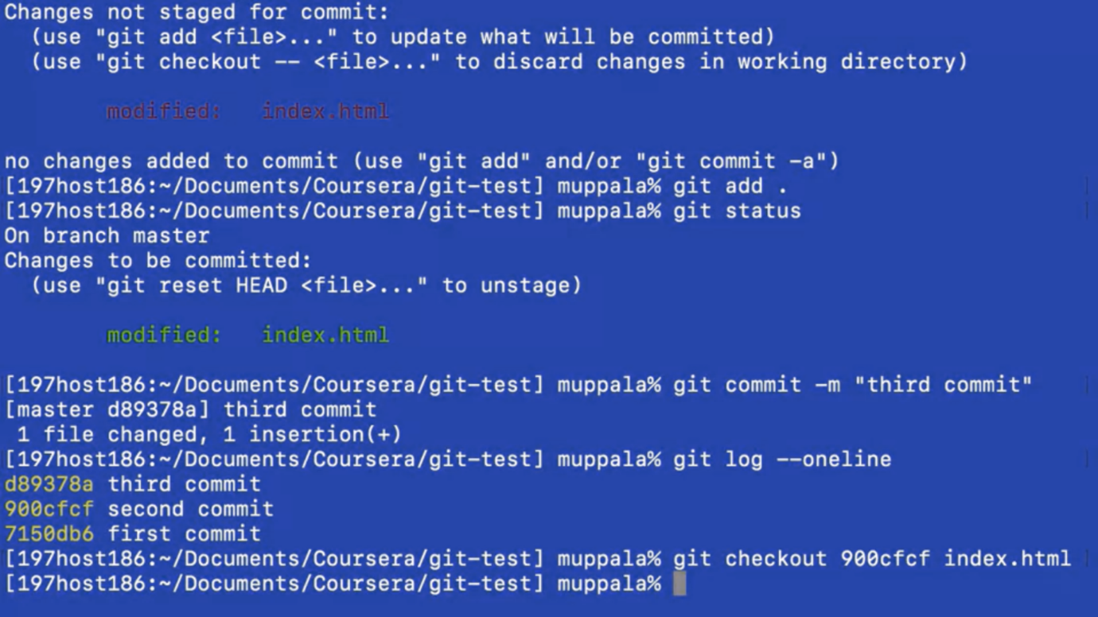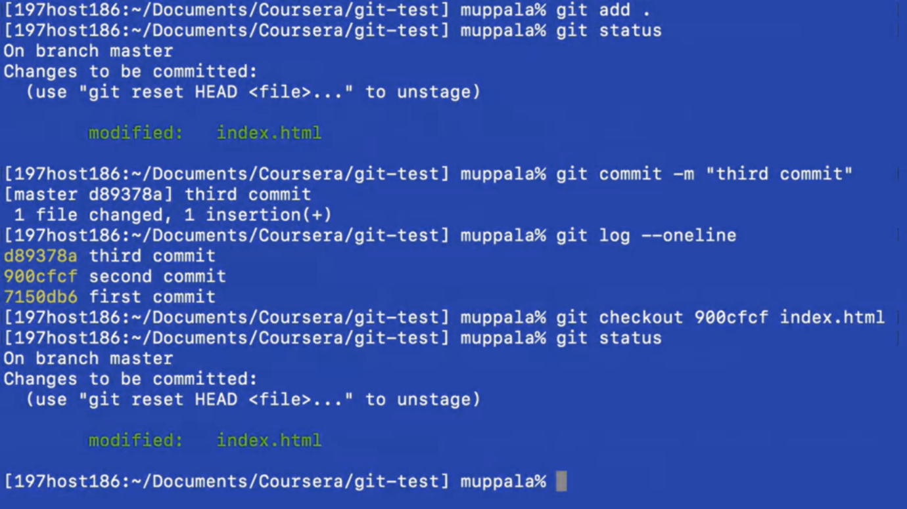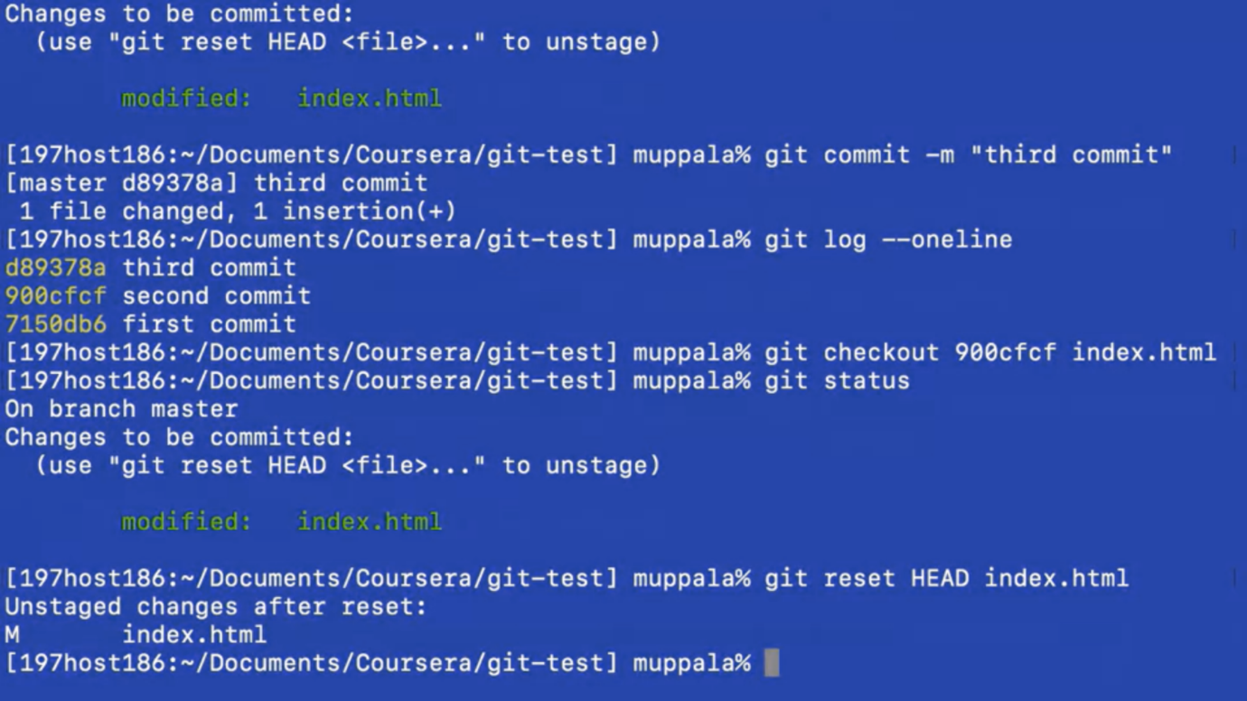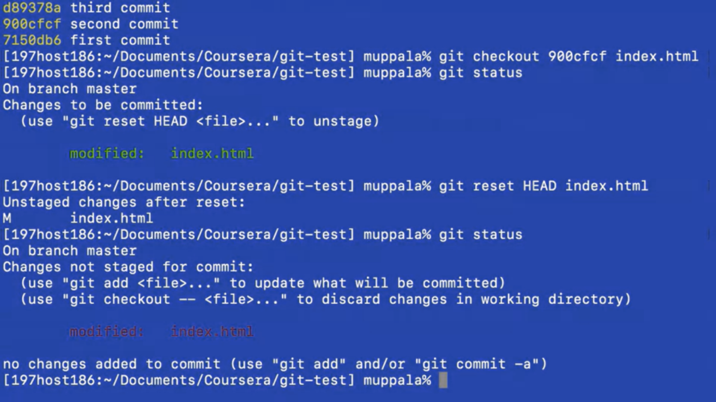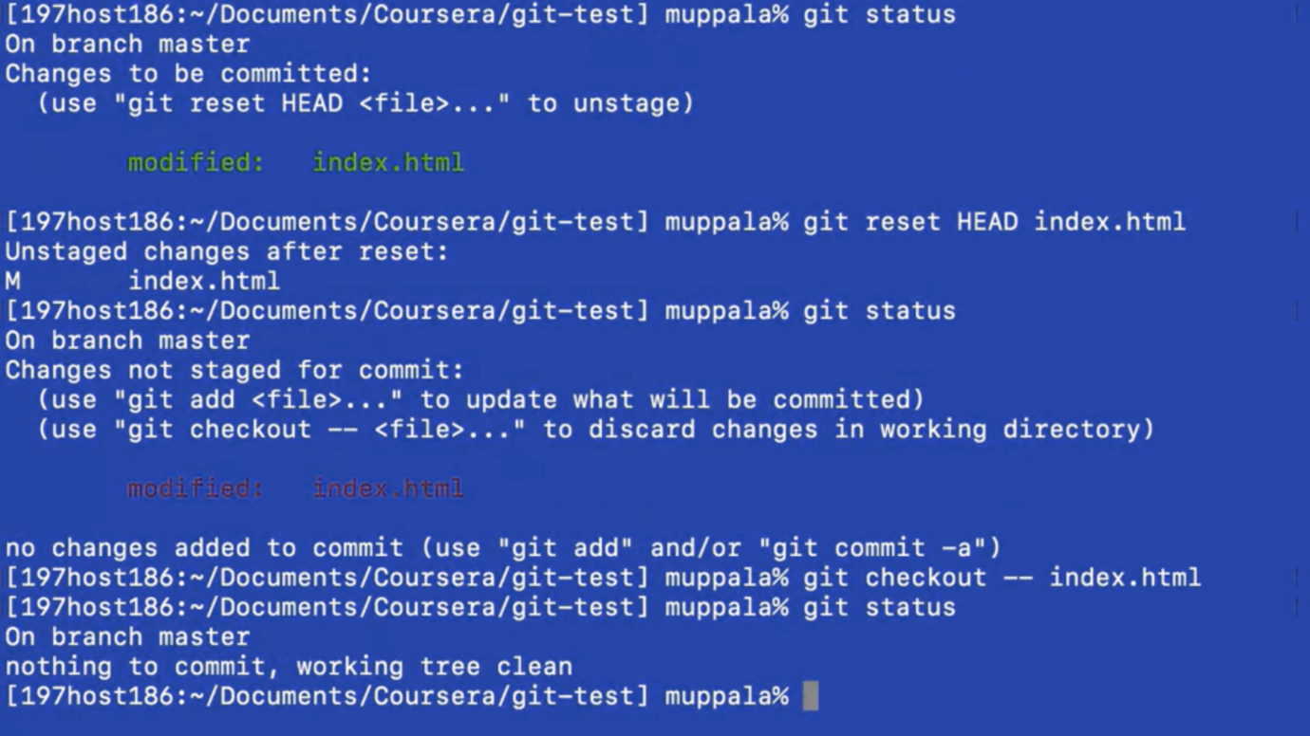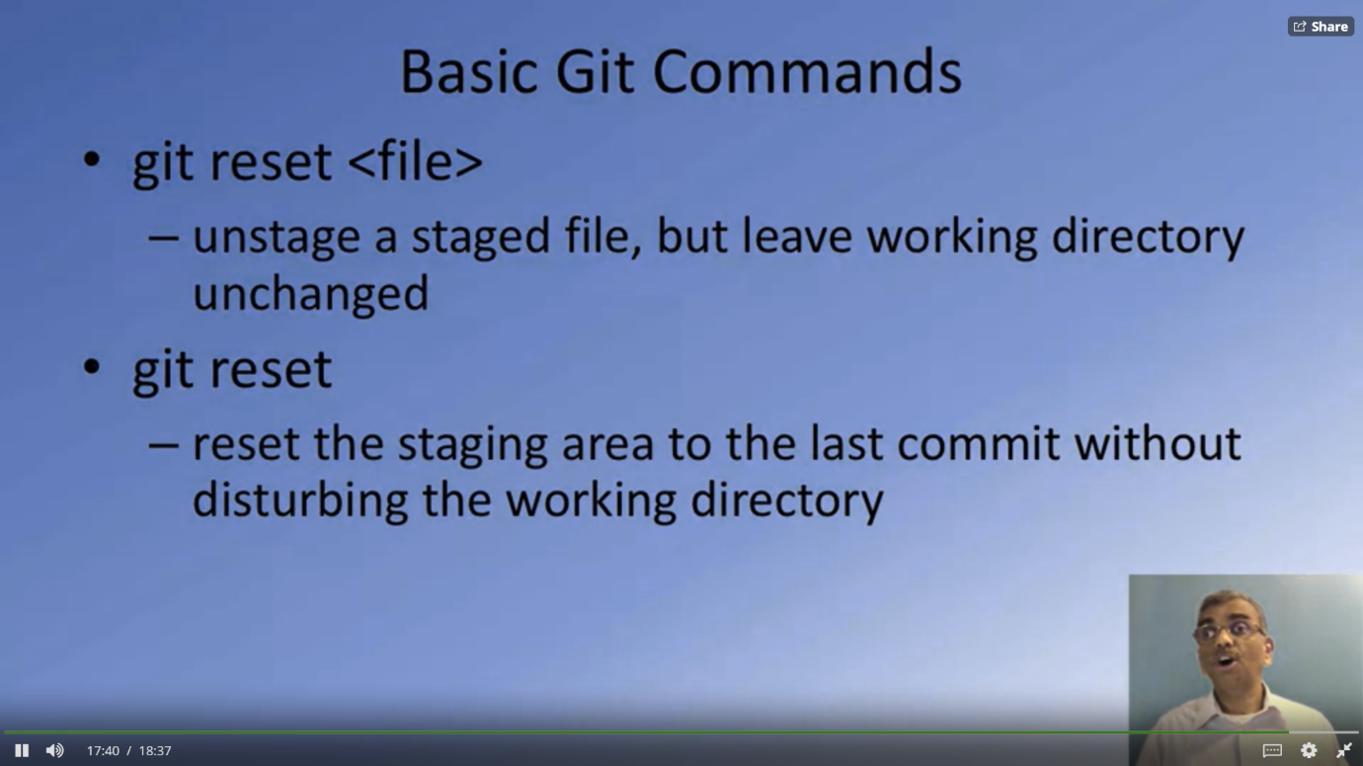

# **Exercise (Instructions): Basic Git Commands**

### Objectives and Outcomes

In this exercise you will get familiar with some basic Git commands. At the end of this exercise you will be able to:

* Set up a folder as a Git repository
* Perform basic Git operations on your Git repository

## **Basic Git Commands**

* At a convenient location on your computer, create a folder named **git-test**.
* Open this git-test folder in your favorite editor.
* Add a file named index.html to this folder, and add the following HTML code to this file:
* <!DOCTYPE html>
* <html>
* <head></head>
* <body>
* <h1>This is a Header</h1>
* </body>
* </html>